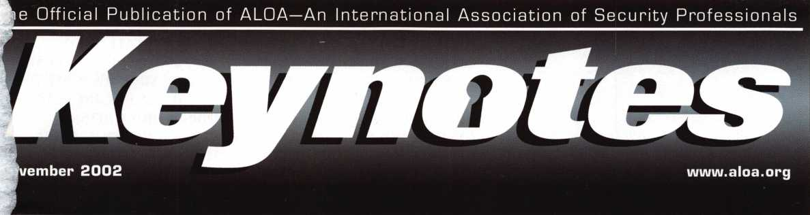

**The Auto Issue**

DODGE VIPER

**Handle with care**

**Plus: PUREAuto's "Pit Creuu" tackles the FORD IMGS**

**Saving Precious Time with the Magic-Pick Scope**

Plus: The New Mas-Hamilton X-09, Lock Picking Mysteries (Pt. 3) PRP (an Institutional Slant], and More



THE FORD UNIVERSAL FLUSH MOUNT KIT #U1 PATENTED YOU ALL ASKED, AS ALWAYS AABLE DID IT. REMOVE ALL FLUSH MOUNT IGNITION CYLINDERS IN LESS THAN 5 MINUTES. NO OTHER TOOL IS NEEDED TO DO THE JOB. THIS IS 5 TOOLS IN I. INCLUDES: FORCE TOOL, 3 DRILL GUIDES, 3 ARBORS & DRILL BITS,

TUMBLER HOLDING TOOL, SIDE BAR PRESSURE TOOL, PLUG TURNING TOOL, 3 SETS OF INSTRUCTIONS WITH PHOTOS FOR ALL CARS. IT DOES FOCUS, MOUNTAINEER, LINCOLN LS, T BIRD, MARK VI11, EXPLORER, ESCAPE, MAZDA TRIBUTE AND MORE. INTRODUTORY PRICE: $155+6 S&H.

The Innovator

1998 and up GM in-dash ignition removal kit.

Patent 5,454,245

Removes plastic ring and chrome cap in seconds; makes access hole to pick side bar; turns cylinder to ACC position.  
Removes lock in less than five minutes with no damage to lock. Your first job will more than pay for the kit.

Introductory price: $70.00 + $4 S&H

1996 and up 8-Waffer Ford Ignition  
Removal Kit and Side Bar Breaker Tool

Patent 5,701,773

Turn ignition to “ON” position in less than 60 seconds for fast removal or use kit to

push side bar in, then turn cylinder to “ON” position without any damage. Fit key, replace same lock. Or use the force tool to  
turn to “ON” position for fast removal in 60 seconds; no damage to waffers. $90*00 + $4 S&H

1994 and up 9-Waffer GM Ignition Removal Tool Kit

Patent 5,454,245

A new system for the future. These locks have side bars longer than the old type and must be in  
the “ON” position to remove the cylinder. My tool will do this. Best of all, you will not damage

the cylinder. You can repair, fit key and replace the same cylinder. Do only one job and you will have the price of the kit paid for. A  
replacement cylinder costsabout $22.00, VATS $45 our cost. Order one today at my special introductory price, and be prepared for  
these new locks. $60.00 + $4 S&H. ***Upgrade it for ’95 Blazers, Suburbans, S-10 Pickups, etc. $20.00 + $4 S&H***

No-Nonsense Squeeze Lock  
Plug Remover

Patent 5,165,158

Now you can remove all squeeze lock plugs in 15 seconds  
or less, from all GM, Ford, Chrysler, AMC, Jeep, no more  
fumbling, gadgets, cut fingers, broken tabs, need for 3  
hands for removal of lock. It’s so easy you can do it in the

dark, while it’s still in the glove box. $50.00 +4 S&H

The GM Persuader

This unique tool will open virtually all GM trunks and doors, through the current year, where tool fits into the cylinder  
in less than 50 seconds. No drilling, pulling, picking, special tools, or electric needed. When customer’s key does not o]  
because: Problem 1: spring retainer popped up into outer shell; Problem 2: one side of side bar sprung offside bar  
does not retract; Problem 3: key or cylinder worn side bar does not retract; Problem 4: key jammed in lock in  
“turned” position, etc. With The Persuader you will open these locks in less than 50 seconds. No damage to lock, just  
repair and replace, nothing to wear out. Yes, if needed, it will open with no key.

Note: because of The Persuader’s capabilities, it will be sold to locksmiths only. $45.00 + $4 S&H

Ford Disc-Out Kit

Patent #4,682,398

A tool kit to remove those stubborn Ford pin ignition locks from 1976 through the current year. These locks incorporate 2 locking  
devices and a hard steel disc across the shear line. They must be in the “ON” position, to release both locking devices, so as not to  
damage the housing. I guarantee the job to take 5 minutes with my kit. Complete Kit $60.00 + $4 S&H

Aable Locksmiths • 86-19 97th Avenue • Ozone Park, NY 11417 • 718.848.8000 • Fax # 718.835.5117  
Frank Markisello guarantees all of his products to do as stated.

Website: [WWW.AABLELOCKSMITHS.COM](http://WWW.AABLELOCKSMITHS.COM)

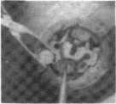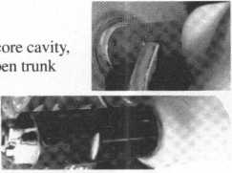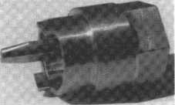

7?

Ford “Quick On

Patent 5,454,245

Now turn all 10 cut ignition cylinders to the “ON” position for fast removal - in less than 60 seconds. Sable, Taurus, all styles, even with airbags. No damage to housing.

$65.00 + $4 S&H

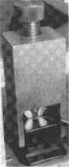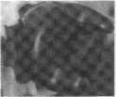

FINISHED CYLINDER

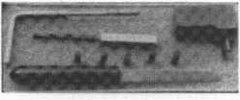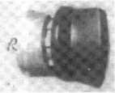

FINISHED CYLINDER

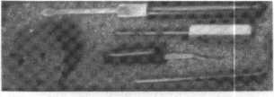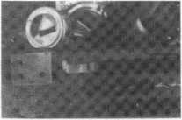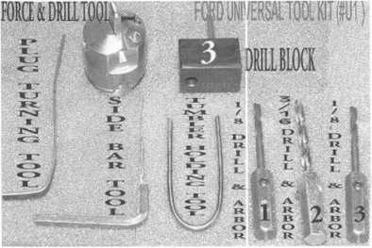

Keep Your Day Job

Come to Las Vegas and invest in your future as a security professional.

Discover classes, workshops, and exhibits that will keep you competitive in today’s marketplace,  
Las Vegas Hilton/Las Vegas Convention Center • July 14-20, 2003

The only gamble is staying home,

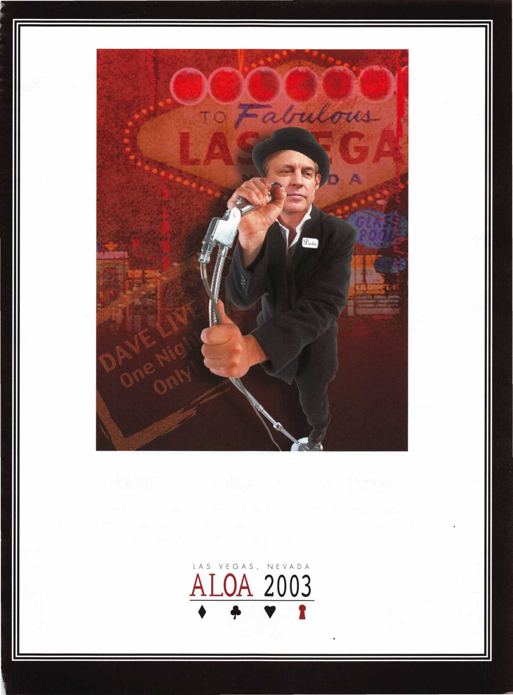

features

The Automotive Issue

Automotive

12

**18**

2002 Dodge Viper: Handle With Care

Auto Guru Jeff Trepanier, RL, takes you inside the red-hot Dodge Viper. But don't go too far with this tricky serpent.

Inside the Ford NGS with PUREAuto's "Pit Crew"

Lots was learned over the past year in the "Pit Crew." Here are some Ford NGS tips learned along the way.

By Tom Seroogy

Auto Tools

**22**

Saving Precious Time with the

Magic-Pick Scope By Sal Dulcamaro, CML

Here's an auto scope all the way from Korea to help you finish jobs faster and make more money.

Safes

**26**

The Mas Hamilton

X09 New (Old) Lock By Greg Perry, CML, CPS

When Mas Hamilton developed their heir to the X07 and X08 models, they didn't fix what wasn't broken, but they changed a few things. Let's take a look inside.

Institutional



Reasons for Taking the PRP By Vernon Kelly

From an Institutional slant, here are some of the reasons for going through ALOA's Proficiency Registration Program.

You might be surprised at how many reasons there, especially for institutional locksmiths. Note: This article was re-printed with the permission of the Institutional Locksmiths Association.

Lock Picking Mysteries, Part 3:

The Rake or Random Method By Sal Dulcamaro, CML

The series continues, this time with a look at the easiest method out there. Only problem is, it also requires the most luck.

|  |  |  |
| --- | --- | --- |
| Statement of Ownership, Management, and Circulation | | |
| 1 Publication Tide  KEYNOTES | >| 2|7 j 7| _ |0 | 7)9 | 2 | 3 Fling Date  10/08/02 |
| Monthly (bi-monthly In July/Aug) | 5. Number of Issues Published ArtnueSy 11 | Member Benefit |
| 7 Coraptet. Mating Address o1 Known Office of Publication (Not prime,) (Street, cHy. county, statu. sntlZIPH) Associated Locksmiths of America, Inc.  3003 Live Oak St. Dallas, TX 75204-6189 | | Contact Person  214/827-1701 |
| 8 Compile Msfflng Address of Headquarters or General Business Office Of Publisher (Notprinter)  SAKE | | |
|  | | |
| Publisher (Name and comprise mating address) ——— —  SAME | | |
| Jim DeSimone  3003 Live Oak St. Dallas, TX 75204 | | |
| SAKE | | |
|  | | |
|  |  | |
| Associated Locksmiths of America, Inc. | 3003 Live Oak St. Dallas, TX 75204 | |
|  |  | |
|  |  | |
|  |  | |
|  |  | |
| 11. Known Bondholders. Mortgagees, and Other Security Holders Owning or  Hotegnq^t Fseoantor Moreof Total Amount of Bonds. Mortgages, or | | |
|  |  | |
|  |  | |
|  |  | |
|  |  | |
|  |  | |
|  |  | |
| The purpose, function, end nonprofit stotue of this orpenpelion and Ihs esa Q Has Not Changed Ouring Preceding 12 Monlha  O Has Changed During Preoodlng 12 Monlht (Publisher must submil arm  PS Pom 3526. Octohor 1999 (See tnatruOtot | nonprofit rates) (Check one)  tanation of change with this statement) | |

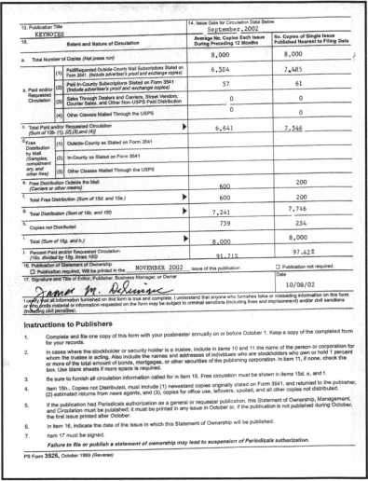

|  |  |  |  |  |  |  |
| --- | --- | --- | --- | --- | --- | --- |
| Executive | 3 | Applicants | 6 Legislative | Classifieds .... | 40 Back Page ... | 44 |
| Calendar | 8 | Core | 10 Update | 38 Associate  Members | 42 |  |

Visit our website at [www.aloa.org](http://www.aloa.org) B Keynotes • November 2002

executive

Volume 48, Issue 10



Additional contact information for the ALOA Board and most Keynotes authors is  
available through "Locksmith Search'" on the ALOA Web site- [www.aloa.org](http://www.aloa.org) or by  
contacting the ALOA office at 3003 Live Oak Street; Dallas, TX 75204; (800)532-2562;  
FAX (214)827-1810; e-mail [aloa@aloa.org](mailto:aloa@aloa.org).

Editor Operations/Membership Manager

|  |  |  |  |
| --- | --- | --- | --- |
| Jim DeSimone | [editor@aloa.org](mailto:editor@aloa.org) | Mary May | [mary@aloa.org](mailto:mary@aloa.org) |
| Technical Editor |  | Director of Information Technology | |
| David Lowell, CML, CMST .... | [david@aloa.org](mailto:david@aloa.org) | Randy McChristian | [randy@aloa.org](mailto:randy@aloa.org) |
| Editorial Advisor |  | Government Affairs Manager/ | |
| John D. Cannon, CML | [jdcannon@worldnet.att.net](mailto:jdcannon@worldnet.att.net) | Chapters & Regional Associations Liaison | |
|  |  | Tim McMullen | [tim@aloa.org](mailto:tim@aloa.org) |
| Art Director |  |  |
| Betty Henderson | [betty@aloa.org](mailto:betty@aloa.org) | Comptroller | Kathy J. Romo |
| Advertising Sales |  | Network Specialist | Greg Jackson |
| Kim Hammond | voice: 817-645-6778  Fax: 817-645-7599 e-mail: [adsales@aloa.org](mailto:adsales@aloa.org) | Membership Coordinator | Shelly Jett |
|  | Convention & Meetings Assistant Karen Lyons | |
| Executive Director |  |  |  |
| Charles W. Gibson, Jr., CAE | [charlie@aloa.org](mailto:charlie@aloa.org) | PRP/Education Coordinator | Ashley Manson |
| Convention & Meetings Manager | | Accounting Coordinator | Stephanie Brothers |
| Kelly Carr, CMP | [kelly@aloa.org](mailto:kelly@aloa.org) |  |  |
| Mail Room Coordinator | Kevin Wesley |
| PRP/Education Manager |  |  |  |
| David Lowell, CML, CMST .... | [david@aloa.org](mailto:david@aloa.org) |  |  |
| Contributors |  |  |  |
| Jerome Andrews, CML | Sal Dulcamaro, CML | Mike Oehlert, CPL, CPS | Tom Seroogy |
| Paul Chandler, CRL | Billy Edwards, CML | Randy Simpson, CML | Charles Stephenson, CPS |
| Claire Cohen, CML | Dan Graffeo, CRL,CMST | Robert Stafford, CML | Dennis Watanabe, CML, |
| Brian Costley, CML, CMST | AJ. Hoffman, CML | Dave Thielen, CML | CMST |
| Ray D'Adamo, CML | Jeff Nunberg, CML, CMST | Greg Perry, CML,CPS |  |

**Mission Statement:** The Associated Locksmiths of America, Inc. is dedicated to enhancing the professionalism, education and ethics among  
locksmiths and those in related sectors of the physical security industry. With approximately 10,000 members in the United States, Canada and the  
freeworld, ALOA is poised to help members obtain the knowledge, the strength, and the confidence to perform their role in the physical security field  
with pride and dignity. But it is only through active involvement and participation that ALOA can fully achieve its potential—and can help members to  
achieve theirs.

**Policies:** Keynotes® is the official publication of the Associated Locksmiths of America, Inc. (ALOA). Keynotes® acts as a moderator without approving,  
disapproving, or guaranteeing the validity or accuracy of any data, claim, or opinion appearing under a byline or obtained or quoted from an acknowl-  
edged source. The opinions expressed by the authors do not necessarily reflect the official views of ALOA. Also, appearance of advertisements and  
new products or service information does not constitute an endorsement of products or services featured by the Association. The Association does not  
accept responsibility for the inaccuracy of any data, claim, or opinion appearing in this publication, due to typographical errors on the part of the  
authors, Association staff or its agents.

**Editor's Note:** This publication is designed to provide accurate and authoritative information in regard to the subject matter covered. It is provided  
and disseminated with the understanding that the publisher is not engaged in rendering legal or other professional services. If legal advice and other  
expert assistance is required, the services of a competent professional should be sought.

**Authors' Payment:** Payment for eligible submissions to Keynotes will be based on the following criteria: topic, time spent and past contributions. Authors who  
regularly submit to Keynotes® are generally paid a higher rate. The latter is especially true of authors who write to fit specific editorial needs and submit said copy  
by Keynotes® deadlines. As a general guideline: Average payment for a 750 word, business or 'light' technical article would be $200. Payment for a 1500 word  
article involving significantly higher time and research efforts would be $400.

Payment will not be offered for articles submitted by ALOA employees or members of the ALOA Board of Directors (unless material is of a technical  
nature), nor for articles submitted by a company that promote that company's products or services. ALOA reserves the right not to pay for articles sub-  
mitted by an individual(s) that promote a particular company's products or services.

**Disclaimer:** The Associated Locksmiths of America, Inc., (ALOA), reserves the right to refuse any article for any reason. Additionally, ALOA reserves  
the right to edit, amend or modify any article submitted for publication in order to preserve technical accuracy, clarity, fairness or grammatical cor-  
rectness. ALOA will make the best efforts to notify the author of any changes. The extent of ALOA's liability for any article or information contained  
therein will be a notice of correction or retraction in the next possible issue.

Keynotes® (ISSN 0277 0792) is published monthly except for the combined June/July issue by The Associated Locksmiths of America, Inc.,  
3003 Live Oak St., Dallas, TX 75204-6186. Telephone: (214) 827-1701; FAX (214) 827-1810; e-mail [aloa@aloa.org](mailto:aloa@aloa.org). Subscription rates for  
members—$15.00 per year. Second class postage paid at Dallas, Texas. POSTMASTER: Send address changes to: Keynotes, 3003 Live Oak St.,  
Dallas, TX 75204-6186. © Copyright 1999, All rights reserved. No part of the contents may be reproduced or reprinted in any form without prior  
written permission of the publisher.

President

Randy Simpson, CML

1. 780-7026 [president@aloa.org](mailto:president@aloa.org)

Secretary

John D. Cannon, CML  
(703) 960-6413  
[socretary@aloa.org](mailto:socretary@aloa.org)

Directors, Northeast

Robert E. Mock  
(215)624-5035  
nedirector@aloa .org

Peter Saraiiian, CRL  
(973)890-9797  
nedirector@aloa .org

William L. Young, CML  
(610) 647-5042  
[nedirector@aloa.org](mailto:nedirector@aloa.org)

Directors, Southeast

Vincent Formon, CML, CPS  
(901) 324-2910  
sedirector@aloa. org

Donald E. Rule, CML  
(662) 324-2658  
[sedirector@aloa.org](mailto:sedirector@aloa.org)

Directors, North Central

Mark E. Blum, CML, CPS  
(517) 482-5809  
[nedirector@aloa.org](mailto:nedirector@aloa.org)

John Soderland, CML, CMST  
(414) 327-5625  
ncdirector@aloa .org

Director, South Central

CD Lipscomb, CML, CPS  
(903)874-3522  
scdirector@a!oa .org

Directors, Southwest

Gordon R. Racine, CML  
(719) 384-4707

[swdirector@aloa.org](mailto:swdirector@aloa.org)

Julie McCluney, CRL

1. 636-5652 swdirector@aloa .org

Director, Northwest

Scott L. Henke, CRL, CPS  
(907) 248-3785

nwdirecfor@aloa .org

Director, European

Hans Mejlshede, CML  
(453)539-3939  
eurdirector@aica .org

Director, Asian

Joe J. Lee, CRL  
(215)289-2404  
[aslandirector@aioq.org](mailto:aslandirector@aioq.org)

Director, Associate

Paul M. Justen  
(800)333-6953  
ascirecfor@alca .org

Trustees

[trLStees@aloa.org](mailto:trLStees@aloa.org)

JohnJ. Greenan, CML, CPS  
(773) 486.2030

Dallas Brooks  
(334) 82(58990

David M. Lowell, CML, CMST  
(800) 532-2562

Past Presidents

1999-2001 John Greenan, CML, CPS  
1997-1999 Dallas C. Brooks  
1995-1997 David Lowell, CML, CMST  
1993-1995 Breck Camp, CML  
1991-1993 Henry Printz, CML  
1989-1991 Evelyn Wersonick, CML, CPS  
19874 989 Leonard Passarello, CPL  
1985-1987 Joe Jackman, CML  
1983-1985 Stanley Haney, CPL  
1981-1983 Louis LaGreco, CPL  
1979-1981 John Kerr, RL  
1977-1979 Clifford Cox, CML  
1974-1977 Charles Hetherington  
1972-1974 Gene Laughridge  
1970-1972 William Dutcher, RL  
1968-1970 Constant Maffey, RL  
1966-1968 Harold Edelstein, RL  
1964-1966 William Meacham  
1962-1964 Robert Rackliffe, CPL  
1960-1962 Edwin Toepfer, RL  
1956-1960 Ernest johonnesen



Keynotes • November 2002

e s i d e n t 1 s

**P r**

journey

Hello Members,

If you've been reading Keynotes lately, looked at the website or gotten a letter recently from Tim McMullen our  
Legislative Manager, you probably already know that ALOA has joined with the Coalition for Auto Repair Equal-  
ity (CARE) to support " The Motor Vehicle Owner's Right to Repair Act of 2001" now in Congress. This leg-  
islation will end the unfair monopoly by big car manufacturers to maintain control over certain service infor-  
mation that results in car owners often being forced to return to the dealership for services.

The Original Equipment Manufacturers (OEM) have used their monopoly and blocked access to needed serv-  
ice tools, information, and required codes to service late model vehicles. Many of ALOA's professional lock-  
smith members face increasing difficulties in providing service to the motoring public due to the unavailability  
of this information from the OEM's.

"The Motor Vehicle Owner's Right to Repair Act" will require the Federal Trade Commission to prescribe and  
enforce rules necessary to ensure the right of a motor vehicle owner to obtain all information required for the  
diagnosis, service, and repair of the motor vehicle in a timely, affordable, and reliable manner. Although the  
bill does not specifically say what information must be provided, ALOA's position is to support the aftermarket  
in the passage of this bill. After it is passed, we will work with the Federal Trade Commission during the reg-  
ulatory process (which comes after the bill is passed) to ensure that all locksmiths have access to this information.

The bill has hit some road-bocks and snags (see page 38 for the latest information), but we are still committed  
to seeing that all locksmiths have the tools, key codes and transponder information from all the OEM's. We  
are working closely with key Senators and Representatives and continuing our relationships with the after-mar-  
ket industry to ensure this happens. There have been many rumors out there that ALOA is trying to "corner the  
market" on this information. Nothing could be further from the truth. The truth is that we want every locksmith  
to have access to this information.

I hope that you will get involved in this important legislative venture, whether you do automotive work or not.  
It is important that we all work together for the betterment of the industry.

See you next month,

Randy Simpson, CML



Keynotes • November 2002

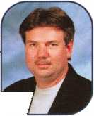

***Visit our Website on www. stamcctv. com***

THE COMPLETE

CCTV PROGRAM ON

FOR STAFF TRAINING

PRODUCTIVITY ENHANCEMENT

STAM **Insight** has been developed to enhance CCTV skills and productivity with many different uses.

Productivity

**€1** System Drawing **€1** Estimation **•** CCTV Training **S** CCTV Reference **tD** Sales/Demo **to)** System Design **to)** Staff Evaluation

| CCTV Content

CCTV Calculators

Demonstration Tool

Estimation

Drawing

Internet Enabled

JmKnowledge Assessment

**Sold in Over 50 Countries**



—-^ ^

M s V I s _

Distributed by:

3003 Live Oak Street  
Dallas,Texas 75204



■ Yes, please send me a FREE PREVIEW CD ROM $9.95 S/H

Name:

Job Title:

Organization:

Address:

Zip/Postcode

e-mail

Fax: ( )

COPYRIGHT © 1996 Security Training and Marketing Pty Ltd. All rights reserved ACN 057 006 541

Country

Tel: ( )

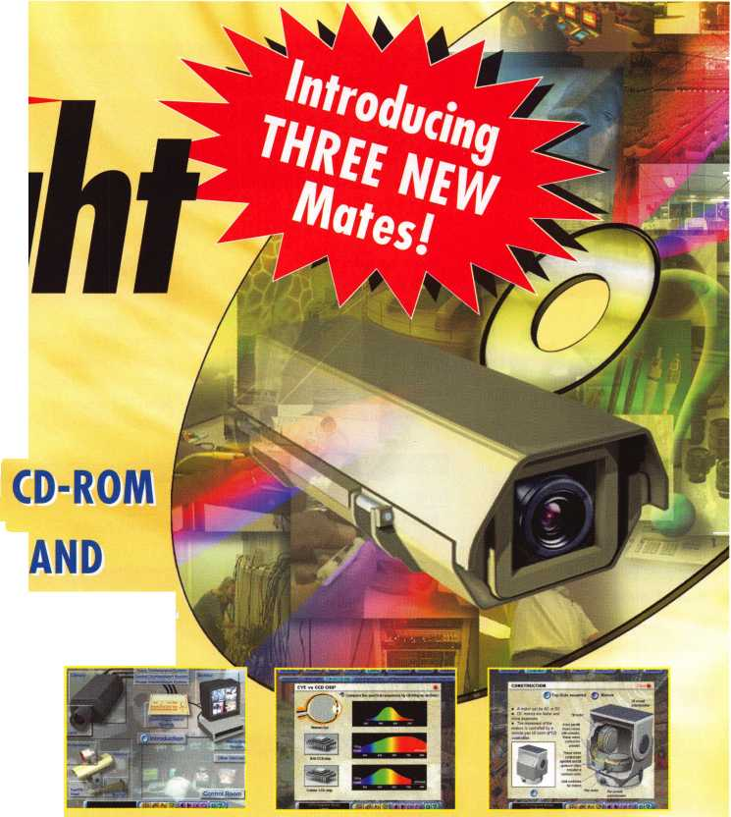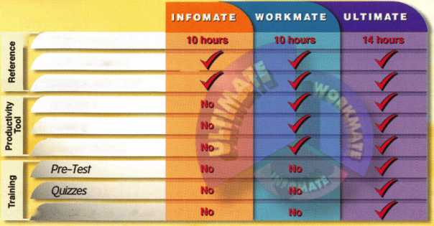

FL

NM



**I i c a n t s**

embership

Cocoa

David Albright

Marianna

Ronald Davis

Sponsor: Don C. Barber

New Smyrna Beach

Terry Bradshaw

GA

Albany

Freddie P. Smith CPL

Savannah

Bruce T. Rahn

Stone Mountain

Richard Williamson

IN

New Harmony

Mike Crews

KS

Wichita

Don Loehr

MA

Randolph

Gary Scanlon Daniel Rosko Peter Quinn

Mark Lacoste Joseph Hunt Brad McMenimon

Ml

Detroit

Jamel Hunt

MN

Faribault

Ken Casperson

MO

Mountain Grove

John J. Ruperd

Sponsor: Clifford D. Lipscomb CML, CPS Platte City

Anthony Large

NC

Boone

Donald K. Ball

Lenior

Milton G. Foster

NJ

New Egypt Charles Redford

Sponsor: Leonard F. Grant Jr

Las Cruces

Jerry Jersrig

Sponsor: Paul H. Gonzales CPL

Rufio A. Ledesma

Sponsor: Paul H. Gonzales CPL

John R. Hernandez

Sponsor: Paul H. Gonzales CPL

NY

Freeport

Scott Kinhackl

OH

Cincinnati

John T. Steele

Sponsor: Glen W. Fessenden CML

OR

Portland

Lee Charles Moore Jr George In ness

PA

Philadelphia Louis Imbesi

Sponsor: Ernest W. Wright

Rl

Providence

Dennis Pereira

TX

Mesquite

Eugene L. Caudill

Sponsor: Mark Caudill CRL

VA

Leesburg

Donald R. Howser

Wl

Green Bay

Chad Diemel

Menomonee Falls

Donald C. Mclnnes

Sponsor: Michael B. Stilwell CRL

Aruba

Oranjestad

Vincent Francis Boekhoudt

Bahamas

Nassau

Gretchen C. Cartwright

Sponsor: Ron R. Burrows



Hertfordshire

Andrew Andrews

Sponsor: Ken Dale

These applicants are scheduled for clearance as members of ALOA. The names are published for member review and comment within  
30 days of this Keynotes issue date, respectively, to ensure applicants meet standards of ALOA's Code of Ethics. Protests, if any, should  
be addressed to the Membership Department and must be signed. Active Membership applicants (a) have worked in the industry two or  
more years. Allied Membership (AL) applicants are not locksmiths, but work in a security-related field. Apprentice Membership (AP)

applicants have worked in the industry less than two years.

Keynotes • November 2002

Pra?Zcts **LOCKSMITH Professionals**

**AD / ID KEY TAGS**

Specifically designed to identify the product you work with daily and promote your business with your custom Ad copy.

back side of tag with 4 lines for key identification

KEYS FOR

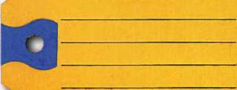

SANZO-ENDKOTT. NY 13760

**Clear Plastic Protective Sleeves** Stock# PPS10

Protect your key tags with W 100 200 500 1000

durable plastic sleeves 11.50 19.95 42.00 68.50

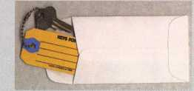

**Key Tag Envelopes**

**TO ORDER:** Choose QTY., Key Tags with Chains or Rings, TAG COLOR and Provide Imprint Copy (printed black only).

ANDOVER LOCK & KEY SERVICE

3221 LAKESIDE HWY

«3)! ANDOVER MA 05242 WJ (508) 626-1111

LAKEVIEW

LOCKSMITH

24 Hour Service , (845) 556-LOCK

Choose from Brass Plated Bead Chains or Chrome Plated Wire Rings

Stock # KTE3 Actual Size: m x 4V4" QUANTITIES100 200 500 1000 2000 3000 5000

Added security and finishing touch when ftKEY TAGS with CHAINS or RINGS 32.00 42.95 83.95 115.00 195.00 269.00 395.00

presenting keys to your customers **your choice of chains or rings - if not specified we ship chains**

* 100 200 500 1000

10.50 17.00 37.50 65.00

**Key Tags Only** (no chains or rings) **- Deduct 10% from above prices** National Logos - No Charge / Custom Logos - Add $25.00 and supply clean B & W artwork

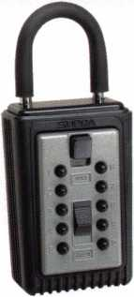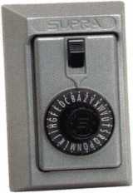

**COMBINATION KEY BOXES**

©SUPRA

**ALL METAL**

**PROFESSIONAL**

Key Storage Lock Box

✓ALL METAL Construction

* Great Economical Pricing
* Simple to set/ Simple to open
* 5 Year Warranty

**PUSHBUTTON**

1-4 37.95 EA. / 5-9 34.95 EA.  
10 or MORE 31.95 EA.

**Set your own combination**

The combination can be changed in seconds — without special tools or disassembly. Changing the shackle combination also automatically changes the combination for the sliding key storage door.

**SERIES LOCK BOXES**

Both models now have weather resistant  
ALL TITANIUM METAL CONSTRUCTION  
with metal back and buttons. Both models  
are also available with PUSH BUTTON  
COMBINA TION LOCKS that are easy to  
set & reset.

Stock # C3-PUSHBUTTON  
Removable KeyBox, DoorGuar  
rubber bumper protects surfaces

Stock #C3-DIAL  
Removable KeyBox  
DoorGuard rubber bumper protects surfaces

**DIAL**

1-4 36.95 EA. / 5-9 33.95 10 or MORE 30.95 EA.

Stock #S5-DIAL Surface Mount Unit

ShurLok has designed an all-metal key storage box that is the safest, most secure lock box on the market. Separate easy to set combinations open the shackle and key compartment — and the combinations can be changed in seconds. The ShurLok is so simple to use a child can open it, yet so versatile it will satisfy the Real Estate professional or anyone requiring key access in a lock box. Unique double combination allows all users access to key(s) while allowing only authorized users access to the shackle and will prevent lock box removal or theft.

**1 to 9 $19.95 ea.**

**10 or more $17.95 ea.**

*if color is not specified we ship blue*

Stock #SLK100R

Brick Red

No Home Should Be Without One The Surface-Mount S-5 Supra Lockbox is a product you can provide to any homeowner, easily priced to your customer in the $50.00 range installed (simple 4 screw installation). Carry one with you at all times to demonstrate - once shown it sells itself!!

**Stock #S5-PUSHBUTTON**

Surface Mount Unit

change

button

(mi)

**10,000**

**Combinations**

**Possible!**

Changing the

for the shackle  
only takes a few seconds  
with a simple turn  
of the change button.

Stock #SLK100  
Blue

**\*$7.00 SHIPPING CHARGE ADDED PER ORDER** NY RESIDENTS ADD APPLICABLE SALES TAX

**SANZO SPECIALTIES, INC. TOLL FREE: 1-800-222-4041**

**BOX 68 ENDICOTT, NY 13760 FAX: 607-748-0507**



***VISA***

***Mast***

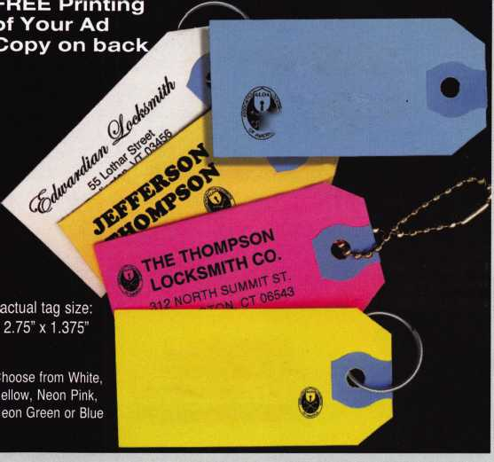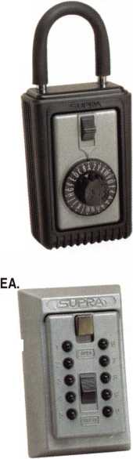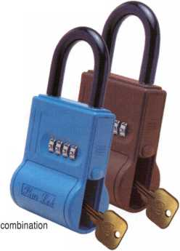

**JAN I DEC NOV**

upcoming

1-2 Auto Servicing Class

w/Jim Hetchler • Greater Dallas Locksmith Association Landy Dyess 972-682-0505

2-3 GHLA

Safe Deposit Lock Svc. with Ken Foo, CPS Ed Stites 979-323-9919 [ditels@fbtc.net](mailto:ditels@fbtc.net)

6 Minnesota Chapter of ALOA Membership Meeting [www.locksmithnews.com](http://www.locksmithnews.com)

20 Central Florida Locksmith Assn. Membership Meeting 7:30pm Contact: Janet Boyer 386-775-3641

23 GHLA

Interchangable Cores with Buddy Clifford Ed Stites 979-323-9919 [ditels@fbtc.net](mailto:ditels@fbtc.net)

27 Pacific Locksmith Association Membership Meeting Tualatin, OR • 6:30pm <http://www.pla-pro.org>

4 Minnesota Chapter of ALOA First Annual Banquet Shorewood Restaurant ($25) Alan Morgan, Jr. [alanmorgan@aol.com](mailto:alanmorgan@aol.com)

7 Pacific Locksmith Association "How To Make Money from Stolen Cars Without Stealing Them" Class <http://www.pla-pro.org>

1 8 Central Florida Locksmith Assn.

Membership Meeting 7:30pm Janet Boyer 386-775-3641



6-10 Yankee Security Conference  
Sturbridge, AAA

Jack Hobin, CPL • 413-565-5152

[www.yankeesecurity.org](http://www.yankeesecurity.org)  
See ad pg. 35

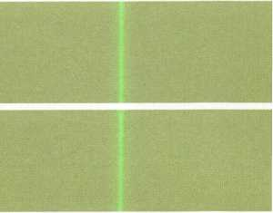

UPCOMING PRP SITTINGS

Nov. 8 ALOA • Dallas, TX • Ashley Manson 800-532-2562, ext. 30

Nov. 9 Yankee Security Conference and Trade Show (see ad page 34)

Sturbridge, MA • [www.yankeesecurity.org](http://www.yankeesecurity.org) 800-209-8266

Nov. 16 Grand Canyon Chapter of ALOA Phoenix, AZ • John Ilk, CRL, CPS: 602-420-2174

Dec. 8 Allied Locksmiths of Youngstown Youngstown, OH Tony Ramunno, CML, CPS 330-782-6204

Dec. 13 ALOA • Dallas, TX • Ashley Manson 800-532-2562, ext. 30

Jan. 10 ALOA • Dallas, TX • Ashley Manson 800-532-2562, ext. 30

Feb. 14 ALOA • Dallas, TX • Ashley Manson 800-532-2562, ext. 30

Mar. 2 Minnesota Chapter of ALOA Maplewood, MN Dana Lee, CML* 612-968-4500

Mar. 14 ALOA • Dallas, TX • Ashley Manson 800-532-2562, ext. 30

April 6 Clark Security Products • Chicago, IL JoanEmrick* 619-718-7308

April 11 ALOA • Dallas, TX • Ashley Manson 800-532-2562, ext. 30

April 26 Colorado Front Range Chapter of ALOA Denver, CO • Gordon Racine, CML 719-384-4707

May 9 ALOA • Dallas, TX • Ashley Manson 800-532-2562, ext. 30

June 13 ALOA • Dallas, TX • Ashley Manson 800-532-2562, ext. 30

June 22 Clark Security Products • Reno, NV Joan Emrick • 619-718-7308

July 11 ALOA • Dallas, TX • Ashley Manson 800-532-2562, ext. 30

August 8 ALOA • Dallas, TX • Ashley Manson 800-532-2562, ext. 30

Sept. 12 ALOA • Dallas, TX • Ashley Manson 800-532-2562, ext. 30

UPCOMING ACE CLASSES

Nov. 6-9 Yankee Security Convention

Sturbridge, MA • 800-209-8266 [www.yankeesecurity.org/conference.htm](http://www.yankeesecurity.org/conference.htm) Fundamentals of Locksmithing I, II, III Basic Safe Svc. and Opening Procedures Electronic Safe Lock Svc.

Nov. 23 Alabama Locksmiths Assn. • Birmingham, AL Amanda Floyd • 334-793-5060 Electronic Safe Lock Svc.

2003 ACE Classes

Jan. 1 1 Wyoming Locksmiths Association

Casper, WY • Investigative Locksmithing I Gener Ficek, CPL • 605-642-4542

Feb.

22-23 Alabama Locksmiths Assn.

Basic Electricity and Intro to Access Control Amanda Floyd • 334-793-5060

Feb 28 -

Mar. 1 Minnesota Chapter of ALOA

Maplewood, MN • Dana Lee, CML 612-722-9181 • [Ill7@qwest.net](mailto:Ill7@qwest.net) Comprehensive 1C I & II (2 days)

Servicing Aluminum Storefront Doors Life Safety Codes and ADA

Mar. 3-7 Fox Valley Technical College • Appleton, Wl Jerry Antoon: 920-735-2406 [www.fvtc.edu](http://www.fvtc.edu) • See ad facing page

March

24-28 SAVTA (see ad inside back cover)

David Lowell, CML, CMST 800-532-2562x18

Apr.

24-26 Colorado Front Range • 9 Classes

719-384-4707

May

17-18 Alabama Locksmiths Assoc

Birmingham, AL • Import Automotive I & II

June

14-18 ALOA 2003 (see ad page 1)

David Lowell, CML, CMST 800-532-2562 xl8

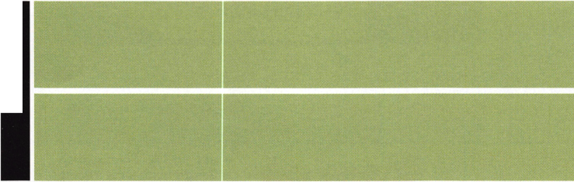

events

9 Wisconsin Indianhead Chapter of 9 ALOA • Membership Meeting Kenneth Briggs 715-726-0687

Grand Canyon Chapter of ALOA 15

Door Closer Class

David Louie 480-967-8568

Grand Canyon Chapter of ALOA

Annual Dinner

David Louie 480-967-8568

15 Grand Canyon Chapter of ALOA Chili Cook-Up Fundraiser David Louie 480-967-8568

Locksmith Training

Sponsored by Fox Valley Technical College • 1825 N. Bluemound Dr. • Appleton, Wl 54912-2277

6-Day Program • Career Change in One Week • March 3-7, 2003

This is a basic locksmithing training course sponsored by FVTC’s Security and Crime Prevention  
Department and conducted by ALOA ACE instructors. Designed for the locksmith shop owner  
who would like to provide entry-level training for new apprentice locksmiths as well as those who

would like to receive professional training that will enable employment with a professional locksmith. The course will allow the student  
to gain enough knowledge to make them a starting apprentice in an existing shop. Job placement locations will be made available at the  
time of the class.

To maintain quality the course enrollment will be capped at 12 students. Enroll early!

Curriculum includes:

Key Blank Identification and Duplication Lockset Servicing, Functions, Finishes Pin and Disc Cylinder Servicing Door Closers

Key Codes and Code Equipment Life Safety Codes ^eY lmPress'on<ng Lockset Installation

Basic Master Keying Lock Pick Opening Techniques *_oc*< ^Y'Pass Techniques Cabinet, Furniture, Mailbox Locks

Exit Hardware

All tools and equipment will be made available for use during training.

Class Hours: 8:30 am to 5:00 pm every day  
Class Attire: Shop clothes  
Course Tuition: $995.00

Course Enrollment: See Susan Egnoski in the Criminal Justice Center

or call 920-831-4393

Note: Enrollment deadline is Friday, September 20, 2002

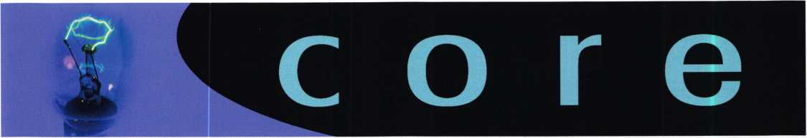

Letters to the Editor

Just finished reading the article written by John Dorsey CML. Excellent article! I have worked as a Correctional Officer for the Colorado Dept, of Corrections for 14 years, 1 1 years at the rank of Sergeant. I have worked Medium Security, Maximum Security, and am currently working minimum secu­rity. 4 of those years I spent in Minimum Security as a Locksmith which is where I got my start in this field. I would still be working as a locksmith there except for the closure of the facility I worked at in July of 2001. I was given a choice to go back to working in Security as opposed to losing my job with the State. I love locksmithing, so I opened my own local shop in addition to working at the prison. One thing I can say about Locksmithing in a prison setting, and I learned this at a "BEST" Lock training from a Federal Prison Locksmith, is that there is NO substitute for preventive mainte­nance. I compared the facility I worked at with another one of the same design, I had a preventative maintenance pro­gram, they did not. They were constantly being called in from home for emergency lock repairs, sometimes as often as once a week. I was called in at most twice a year, always to remove foreign objects from key cylinders placed there by disgruntled inmates. So, if you ever get one of those gravy "Institutional Locksmith" jobs remember, an ounce of preven­tion goes a long way (and it never hurts to look like you're always busy).

Phillip Poindexter #43065 Pd's Lock & Key Florence, Co.

And the winner is ...

Congratulations to Jeremy Rodocker, CPL, CPS of Rodocker's Architectural Security Company in Fort Wayne, IN. By send­ing in his dues payment early this year, Jeremy put himself in the position to win an early-bird prize, and his name was randomly drawn from our early-bird group this year. Jeremy wins valuable computer dispatching software from Desktop Dispatcher. Way to go, Jeremy, and stay tuned next month for more winners!

In Memory

Two Maryland treasures were lost recently. The oldest, largest and most prestigious White Oak in North America, a 460- year old landmark called the Great Wye Oak fell on June 7. And on that same day, a Baltimore legend, superlative lock­smith and an exceptional human being, Mr. Robert Easter,

Sr., also came to rest. Mr. Easter (or as he was affectionately called, "Mr. Bob") will be greatly missed. He will go down in history amongst the names like Earnest Johannsen and Bill Reed as one of our renowned locksmiths.

We're all going to go someday. When it's my time, I can only hope that folks will be able to say just half as many good things about me as they have about Mr. Bob. I feel privileged to have met him early in my career, and I looked forward to getting to know him better. He was someone everyone liked. Mr. Bob was a man of great character and he loved locksmithing. Even at age 76, he was still attending classes, always wanting to learn more. He was a role model for young locksmiths. I observed his interactions with his employees and could see that they loved him. Yes, Mr. Bob made Easter a household name in Baltimore. His success was a byproduct of the love he had for our profession. Like the great Wye Oak, Mr. Bob became old and frail. The winds of time caught up to them the same way. Both were mighty and left their mark in their own unique way. So here's to you, Mr. Bob: You will be missed.

—Lance Edwards

New Certifications

CRLs

Neil Allen  
Kenneth Blanchard  
Hank Fuller  
John Robb  
Hank Tenenbaum

Kissimmee, FL Portland, OR Elmira, NY Ridgecrest, CA Fairfax, VA

CPSs

Greg Jordan Bellevue, WA

Let Us Know!

If you have an opinion to offer on ALOA, the state of the industry, or life in general, we want to know about it! Submissions to the "Mailbox" section of Keynotes are printed on a space-available basis. Write to: "Letters to the Editor"; ALOA; 3003 Live Oak Street; Dallas, TX, 75240; FAX 214/827-1810; e-mail: [editor@aloa.org](mailto:editor@aloa.org).

Need Help?

At ALOA, we want to make sure you are getting as much bang for your membership dues buck as we are able to give you. If you have had problems getting membership services, or have a question regarding member services, please con­tact Bill Gibson, executive director, at 800/532-2562, or e- mail: [charlie@aloa.org](mailto:charlie@aloa.org).

**10**

Keynotes • November 2002

FORD UNIVERSAL IGNITION DRILL  
GUIDE AND FORCE TOOL KIT  
(PATENTED)

By Frank Markisello, CRL

A

s many of you know, there have been problems with the Ford Focus igni-  
tion locks since its inception. Now there are four - count ‘em, FOUR —  
different types of locks, just for this model! So before you jump the gun

and buy a tool that does only one type of these locks, take a look at what Aable has  
designed. My company, Aable Locksmiths (aablelocksmiths.com) has designed a  
Ford universal flush mount ignition removal kit. This kit will allow you to remove  
all four types of Focus locks fast and easy. It also has a force tool that will take off  
the removable face disc on the Strattec #703596 and the new #707592 in seconds  
flat. This kit will also remove the larger diameter ignitions #707596, which has a  
side bar. It takes off the smaller diameter ignitions #707592, which have no side  
bar and replaces #706229 from Strattec. Also, other models Thunderbird,  
Continental, Mark VIII, Lincoln, Is, T-bird, Explorer, U152, Mountaineer and other  
models that use these type of locks are serviceable with my new tool. No need to  
buy different types of tools just for the Ford ignition. My kit has everything you  
need to do the job, and a tool to make disassembly and reassembly fast. Best of all,  
it comes in at a price all can afford - you’ll get your investment back in one job.  
Don’t get stuck on one of these jobs, get the (ul) kit today, and be prepared.

The kit has one force tool, three drill guides, three numbered drill bits and arbors, one side bar pressure tool, one plug turning tool, one tumbler holding tool, and three sets of photo instructions. All tools are made of top quality tool steel to last a lifetime. For any information on this kit contact, contact me, Frank Markisello, at 718/848 8000, or visit our website at [www.aablelocksmiths.com](http://www.aablelocksmiths.com).

Keynotes • November 2002

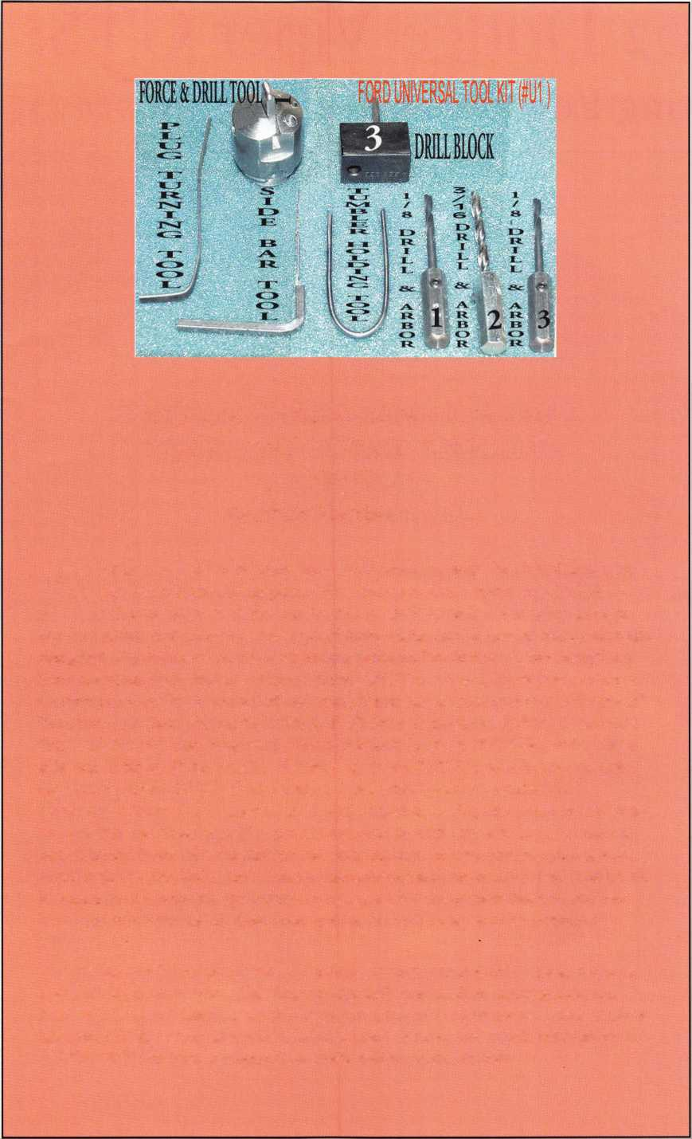

2002 Dodge Viper GTS:

Cutting Edge Lock Technology by Jeff Trepanier, RL



**2**

Keynotes • November 2002

This article was fun. The Viper is a sleek, muscle-bound growler. It’s a beauty to look at, with clean lines and smooth performance. They’re impractical for me, as I’m 6’8” (or 5’2o” as I usually tell peo­ple over the phone), and can’t get my legs under the low, cockpit-like steering area. But I was able to make my way around this Viper GTS, and there are some notable advances I’m sure you’ll be inter­ested to hear about. Let’s check it out:

Keynotes • November 2002

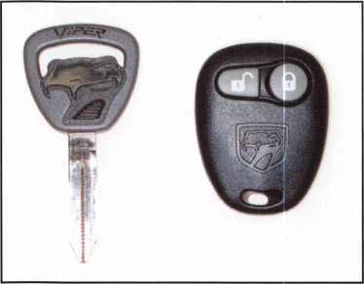

photo 2

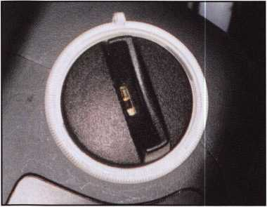

photo 3

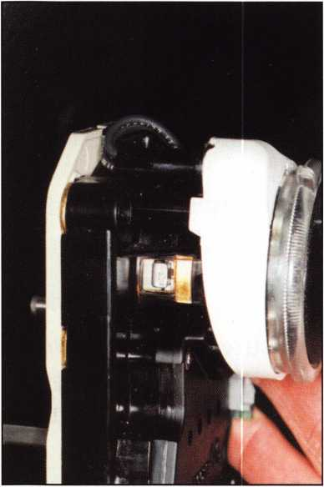

photo 4



photo 1

1. GRRR!!!
2. The 8-cut black and gray Viper head transponder key along with the very simple remote for the Viper, which (un)locks the vehicle. Locked, the factory alarm is automatically set. You must have the remote to disarm it and to unlock the Viper. THERE ARE NO DRIVER OR PASSEN­GER KEYWAYS ON THIS CAR!!
3. The ignition on the right side of the steering column, with the ring around the ignition illuminated. There are three #20 torx screws used to hold the upper and lower shroud together. After removing the screws, gently unsnap the column shroud.
4. The ignition cylinder with the shroud separated. Complete shroud removal is not needed if you are just removing the ignition cylinder. In the ON position (preferably using a key), push in the active retainer and pull the ignition out. The retainer is located between the top and bottom of the ignition cylinder housing on the front, or the 9 o’clock position.
5. The key in the ignition cylinder. The active retainer is at the end of the ignition at the top of the photo. With the key inserted,

it pushes out the retainer at the end of the ignition.

1

**14**

Keynotes • November 2002

1. A closer view of the ignition without the key. To disassemble the ignition, turn the ignition as far as it will go, push down on the round pin located under the black bezel and contin­ue to turn and remove the ignition plug from the housing.
2. The ignition plug removed. Also seen here are eight opposing wafers and a sidebar.
3. The locking compartment lid located between the back of the driver’s and passen­ger’s seats.
4. Here’s one method for removing the plug. Using two small screwdrivers, push on each side of the plug retainers and pull the plug out.
5. The locking compartment plug removed.

Also seen here are three wafers in positions 6, 7 and 8.

1. A rear view of the vehicle. Also seen is the trunk lock, located underneath the white stripe to the right.
2. The small storage area at the rear of the vehi­cle, which is slightly larger than the spare tire. To remove the trunk lock, gently pull down the fabric panel at the rear of the vehi­cle. The speaker cover need not be removed; it will stay with the panel. With this pulled down, you will expose the trunk lock.
3. A 10mm nut being removed at the top of the rear glass cable release assembly. There is a second 10mm nut located at the bottom of the bracket.

The cable release bracket assembly, removed. Also seen here is a 1 1/4-inch nut holding the trunk lock in place. The lower bracket stud is also shown. With the nut removed, the trunk lock will just pull right out from the outside rear of the vehicle.

14-

photo 5

photo 7

photo 8

Keynotes • November 2002

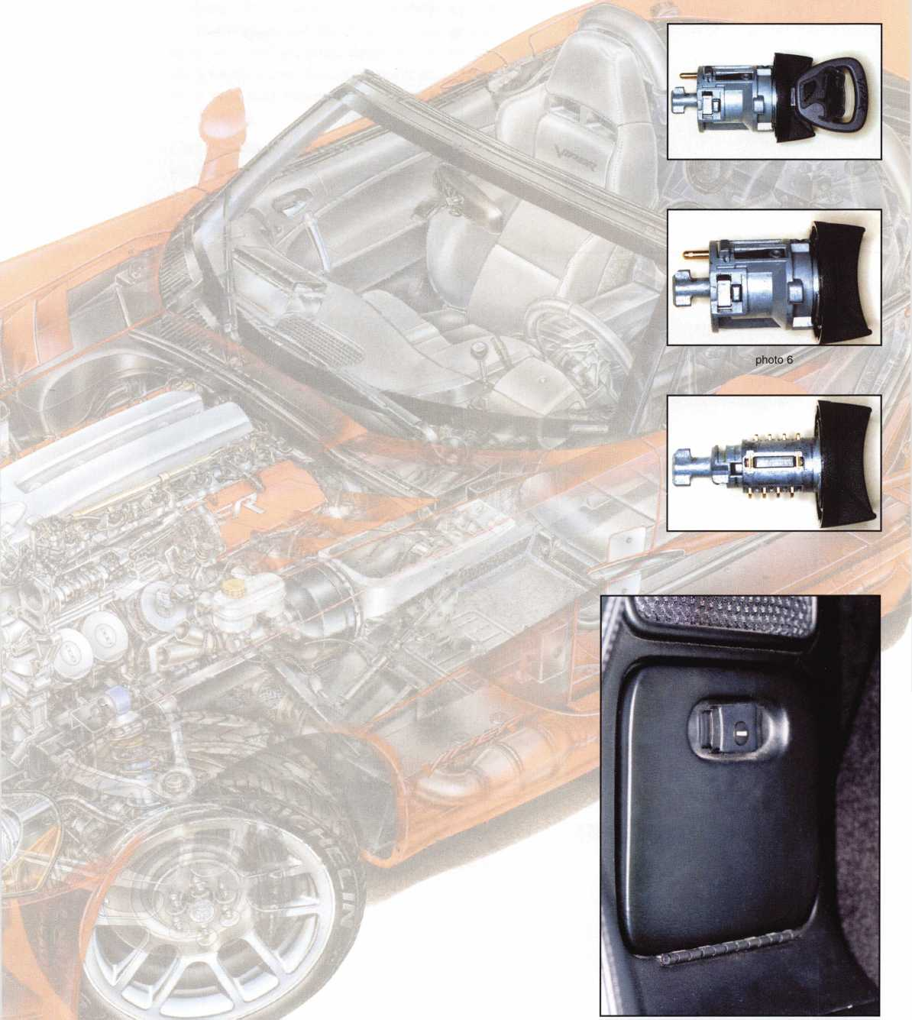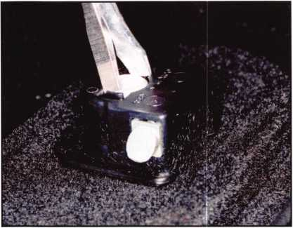

photo 9

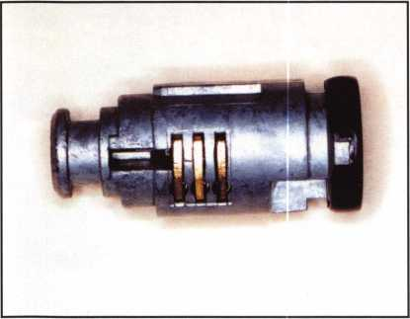

photo 10

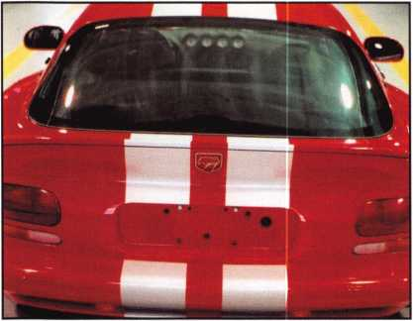

photo 11

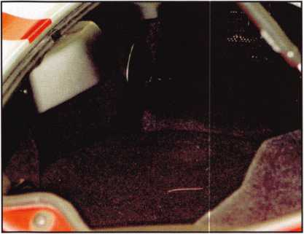

photo 12

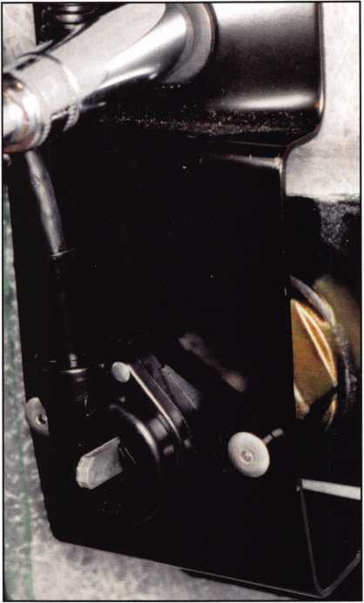

photo 13

1. A bottom view of the trunk lock. Also shown are seven wafers through the drain hole in positions 2-8. We could not tell if there is a sidebar in this lock. If not, then you can pick and impression this lock.

ATTENTION!! At this point in the article, you should stop reading as if you are actually trying to learn how to service the vehicle. Although I finished servicing the doorlocks,

I highly encourage you to send this type of work to the dealer. If you are called to open a 2002 (or higher) Viper, you will have to use a method that gets you access from the inside of the vehicle (e.g., spacing open the door and using a tool to unlock the car from the inside).

1. Messing with a door without keyways is a good way for a locksmith to get himself into an insurance nightmare.
2. The passenger door with the panel on. LEAVE IT THIS WAY!

Keynotes • November 2002

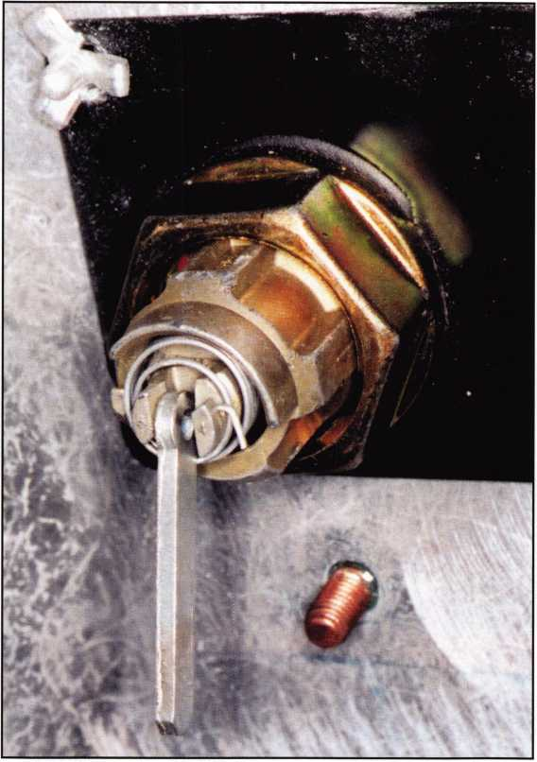

photo 14

1. The passenger door with the panel off. If you break anything in here trying to service the doorlock, you are in for it. You cannot make money on this door­way; it’s a losing proposition. STAY AWAY - SEND IT TO THE DEALER!

All in all, the 2002 Viper lives up to its name. It’s a high end vehicle that can net you some nice cash, and it’s fun to work on cars that look this nice. But it takes a steady hand and a clear head. If you make one wrong move, this car can strike and its venom can be very costly. Handle the 2002 Viper with care, and enjoy it!

Author’s Note: As I stated, I have serviced all of the locks on this vehicle, bypassing airbags, computers, elec­trical equipment and the like. ALOA does not recom­mend that you try this, but if you have a question about servicing the entire 2002 Viper, feel free to contact me at 262/770-1869. See you next time. Q

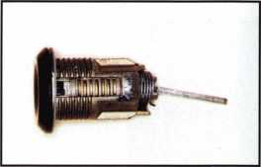

photo 15

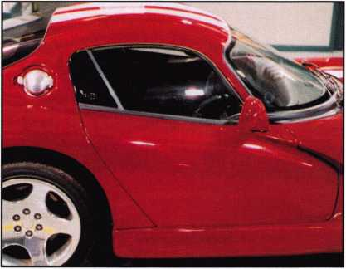

photo 16

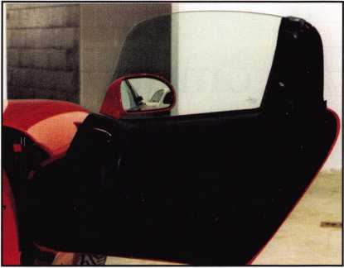

photo 17

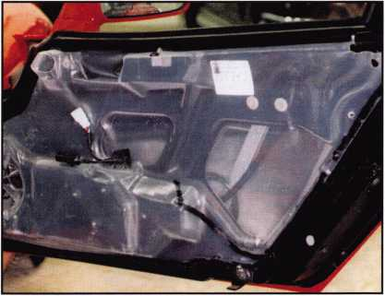

photo 18

Keynotes • November 2002



Automotive: Inside the FORD NGS with PUREAuto’s “Pit Crew”

(Part i in the “Pit Crew” Series)

By Tom Seroogy

Over the last year, I have visited eight different cities around the United States as the Pit Chief of Lockmasters’ 2002 PUREAuto™ Automotive Weekend. Thanks to you, the locksmiths, this year was a great success.

With the season over, we now have time to collect our wits and put into print some of that information we presented throughout last year. For those who have had the opportunity to spend a PUREAuto

weekend with PUREAuto’s Pit Crew (Tom Mazzone, Tom Lynch, Randy Mize, Jeff Trepanier and myself), you’ll find that our constant research has uncovered many deviations and/or changes in the systems on which we are teaching.

For those of you that have not had opportunity to participate in a PUREAuto weekend, this next series of articles will shed a little light on the type of infor­mation you’ve been missing. Following is the first in a

a

**8**

Keynotes • November 2002

series of articles on using the Ford NGS diagnostic tool, manufactured by Hickok Inc., to generate keys and perform diagnostic work for a PATS equipped Ford vehicle.

Note the following warnings before performing any key programming or diagnostic function using the NGS:

1. Make sure the correct key is being used. Incorrect keys are the number one reason for key program­ming failure.
2. Make sure the ignition lock is in the ON position. Indicator lights on the Instrument Panel Cluster should illuminate.
3. Know under what module the PATS (Passive Anti Theft System) function is stored.
4. Check Diagnostic Trouble Codes (DTCs) and Parameter Identification Data (PIDs) before working on a vehicle with an unknown history
5. Never use an outside power source for the NGS. Power for both the NGS and the vehicle being serviced must be coming from the same source (battery).

There are two tasks a locksmith can perform on a Ford vehicle using the NGS diagnostic tool - diagnos­tics and service. While there are several diagnostic functions available, the locksmith is typically con­cerned with only two - Diagnostic Trouble Codes (DTCs) and Parameter Identification Data (PIDs). These and all other diagnostic work are done using the RED or the BLACK Diagnostic cards (the pro­gram cards that come with the NGS). We will discuss these functions and the use of these cards in a later article.

Instead, the focus of this article is on the service functions available to the locksmith. The service functions are used to make changes or adjustments to the various systems within the vehicle. Adding keys is just one example. Changing time delays, indicator chimes, vehicle calibrations and ABS functions are others. In order to access the service functions, the GREEN service card must be used. Using the Service card, the locksmith has access to six key/module relat­ed functions:

1. IGNITION KEY CODE PROGRAM - Add keys to the system WITHOUT erasing or deleting currently programmed keys. Up to eight keys can be programmed into PATS II- equipped vehicles.
2. IGNITION KEY CODE ERASE - Erases all keys currently programmed into the vehicle. Once programming is complete and all keys are erased, two keys must be programmed into the vehicle.
3. SPARE KEY SWITCH ENABLE/DISABLE - This function enables and disables the onboard programming feature for adding spare keys into the vehicle. When enabled, the onboard program­ming method is available for adding keys. When disabled, onboard programming cannot be used to add keys.

NOTE: over the last year, we have found many bugs with this function. In some instances, the functioning of the ENABLE/DISABLE feature was reversed. More recently, we’ve found that keys can be added using the onboard programming procedure regardless of this system’s status. Hickok and Ford are currently looking into this matter.

1. PARAMETER RESET - Modules within a Ford vehicle communicate with one another, each hav­ing its own “ID.” When a new module is intro­duced into a vehicle, it often will not start until the new module has been properly initialized into the system. To perform module initialization, select this function. When programming is com­plete, disconnect the NGS and cycle the ignition ON-OFF five times.

NOTE: With transponder-equipped vehicles getting older, more are involved in accidents and repairs that require module replacement. Many small garages and body shops are unable to start the vehicle after a module has been replaced. This is a perfect opportu­nity for the locksmith to offer his/her services.

Module failure is also becoming more frequent as the vehicle’s age. Our office finds that the HEC module tends to have the highest number of failures.



Keynotes • November 2002

1. SET UNLIM-  
   ITED TRANSPON-  
   DER CODE - This

function is used to acti-  
vate and use the  
Unlimited Key Function

offered in many late model  
Ford products. Currently it is available only to  
vehicles that use the new “Jewel” key - STRAT-  
TEC 599114/599179 - which uses the Texas  
Instrument Encrypted Wedge transponder chip.  
This particular function is used to set the eight-  
digit password required prior to enabling the  
Unlimited Key function.

This function will be discussed in more detail in a later article.

1. UNLIMITED KEY ENABLE/DISABLE - This function enables or disables the Unlimited Key function. Setting an eight-digit password using the Set Unlimited Transponder Code func­tion is required before this mode can be enabled and/or disabled.

These are very brief descriptions of the programming or service functions available to the locksmith. These will be discussed in more detail in later articles. For now, let’s first discuss the steps necessary to get to these functions. For those not acquainted with the NGS, programming more often seems like a maze of steps that leads to confusion and frustration than to programmed keys, happy customers and a handful of cash.

Still, programming really only involves five easy steps. (These steps are for PATS Il-equipped vehicles;

PATS I vehicles require four steps that are slightly different.)

Before following these steps, connect the Data Link Connector (DLC) of the NGS to the DLC connector in the car; insert a transponder key into the ignition lock and turn it to the ON position. The NGS screen illuminates and the system will initialize, bringing you to the first menu. Once here, use these five steps:

1. Select SERVICE BAY FUNCTIONS and hit the TRIGGER button.
2. Select the correct module (see following list) and hit the TRIGGER button. Ford vehicles store the transponder programming function in one of seven possible modules. These include:
3. PCM - Powertrain Control Module
4. PATS - Passive Anti Theft System
5. HEC - Hybrid Electronic Cluster
6. ICM - Instrument Cluster Module
7. SCLM - Steering Column Lock Module
8. SCIL - Steering Column/IP Lighting
9. VIC - Virtual Image Cluster

In order to access the programming mode, the cor­rect module must be known. Use the latest applica­tion guide to determine the correct module for the vehicle being serviced. If the module is not listed or not known, select one of the above modules and con­tinue. If programming cannot be completed, hit the CANCEL button and select another module.

1. Select ENTER SECURITY ACCESS and hit the TRIGGER button.
2. Select the correct year/model and hit the TRIGGER button.
3. Select the program function you need to perform.

Once programming is complete, it is critical with some vehicles, to use the correct disconnect sequence when removing the NGS from the vehicle. This procedure has evolved over the last few years and will always remain the topic of debate. But for the most part, an incorrect disconnection affects only a few models, and even then, the problems are minor or short lived. To date, the consensus seems to be that when the NGS indicates that the function has been completed:

Keynotes • November 2002

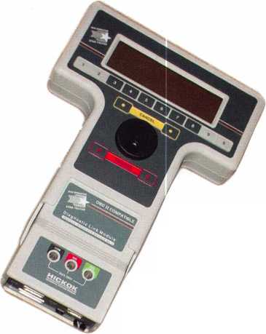

1. Disconnect the NGS’s DLC from the vehicle.
2. Wait 20 seconds.
3. Turn ignition to the OFF position and remove the key.

If the Ignition Key Code Erase was used, it is neces­sary to program two keys into the vehicle. Continue

the procedure:

1. Insert first key into ignition lock and turn to ON position. The THEFT indicator lamp will light solid for approximately 2 seconds.
2. When the THEFT lamp goes out, turn the igni­tion lock to OFF and remove the key.
3. Insert second key into ignition lock and turn to ON position. The THEFT indicator lamp will light solid for approximately 2 seconds.
4. When THEFT lamp goes out, turn the ignition lock to the OFF position. The keys are pro­grammed.

If on the first key, the THEFT lamp lights stays on

solid and does not go out after approximately 2 sec­

onds, remove the key and wait 10 seconds. Introduce the second key and program using the above steps.

Approved disconnection procedures from previous years include:

1. Turn ignition lock to OFF position and remove key.
2. Wait 10 seconds.
3. Disconnect NGS DLC from vehicle.

Or,

1. Disconnect NGS DLC from vehicle.
2. Turn ignition lock to OFF position and remove key.
3. Wait 10 seconds before using or programming keys.

If you have any questions on transponders, transpon­der programming or need transponder equipment or key blanks, contact me, Tom Seroogy of Lockmasters, at 800/654-0637. Q

Buying From Nebs

Products

Savings

Put a lock on

eaH, order

Professional Business Products, your  
Associate ALOA Member, offers you  
lower prices, two color AL0A logo  
on standard forms and rebates to ALOA!

For more information, visit us online:  
[www.professionalbusinessproducts.com](http://www.professionalbusinessproducts.com)  
or call 1-800-355-6322 for our catalog.

*Professional*

*Business*

*Products*

Keynotes • November 2002

**21**

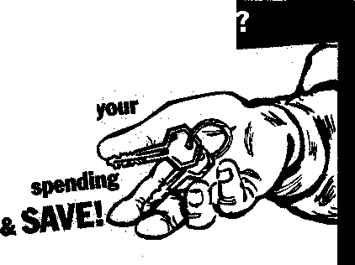

Magic-Pick Scope

By Sal Dulcamara, CML

v,as been modifjed f



Keynotes • November 2002



Photo 1

Photo 2

Like those in many other professions, it is not unusual for locksmiths to borrow tools first used in another profession and appropriate those tools for their own specialized needs. One such tool is the otoscope, commonly used by doctors to examine the inside of our ears or other body cavities. This useful device, which makes it easier to see into small dark openings, has found its way into the tool cases of many a lock­smith. In slightly different applications, it has proven to be a useful tool for both locksmiths and safe tech­nicians alike. Otoscopes, in various forms, are avail­able from a number of security related companies.

One very new version of the tool was introduced and

demonstrated at the recent ALOA show in Chicago (Rosemont).

Photograph i shows the Magic-pick Scope from Jho’s Master Locktools. This version of an otoscope has been modified for, and targeted to, the automo­tive locksmith. Lower and to the left of the scope, you can see four probes/attachments, and an Allen wrench to attach them. A close-up of the attachments can be seen in photograph 2. Actually, the two attach­ments at the bottom are broken key extractors. When used in conjunction with the Magic-pick Scope, they can become more effective than the typical extractor tool. Above the two extractors are a straight probe

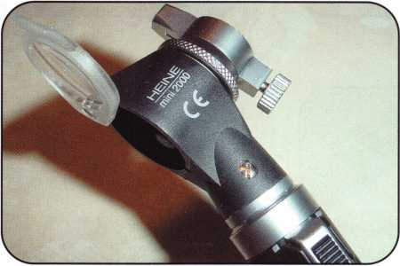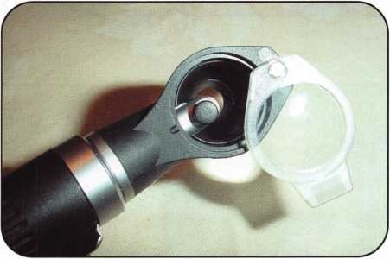

Photo 3

Photo 4

Keynotes • November 2002

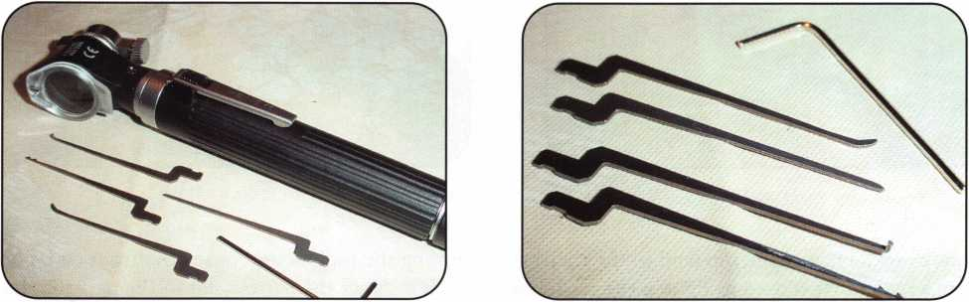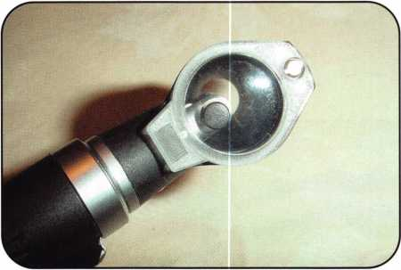

Photo 5

and a hook pick. Then at the top (and to the right) is the Allen wrench that is used to tighten the set screw that secures the attachments to the device.

A closer side view of the scope can be seen in photo­graph 3. On the back side, there is a flip up magnify­ing lens, and on the front side there is the part that holds the attachments. That part can be rotated 360 degrees to position your attachment to a more com­fortable and effective spot for your needs.

Photograph 4 shows the scope from a normal viewing position. The light source can be seen extended into the opening. The magnifying lens is currently flipped to the side. The lens has been flipped into place for magnified viewing in photograph 5. The scope is typi­cally more effective when the light is switched on.

\

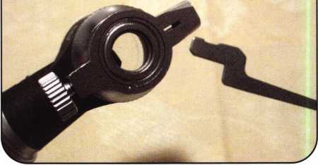

Photo 6

Turning the tool around to see the front end, photo­graph 6 shows the narrow slot in the part that holds the attachments. You can see that the offset end of the attachment will fit inside that slot. In a side view, photograph 7 shows the attachment being inserted into the slot. After full insertion in photograph 8, the Allen wrench is used to tighten the set screw which locks the attachment firmly in place. In photograph 9, I am pointing to the thumb screw that locks the rotating attachment holder in place. The straight probe is useful for (auto lock) disc tumbler reading.

By loosening the thumbscrew (photograph 10) and rotating the holder, it is possible to reposition the probe for reading double throw tumblers. One group of tumblers can be read at the top of the keyway and

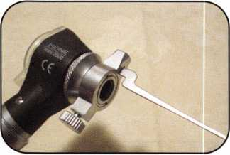

Photo 8

Photo 9

Photo 7

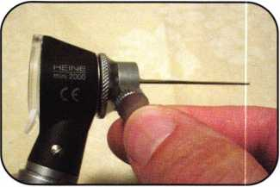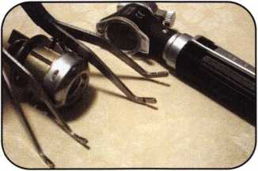

Photo 10

Photo 11

Photo 12

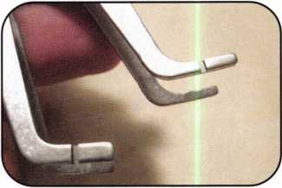

Keynotes • November 2002

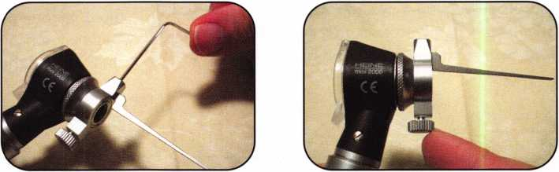

the remaining tumblers (staggered in alternate spaces) could be read at the bottom of the keyway.

Before you can view and read anything, though, you have to deal with the pesky problem of spring loaded keyway shutters. Photograph n shows the Magic-pick Scope, a Ford (8-cut) deck lid lock and two interesting keyway shutter hold-open devices. A close-up view of the tips of the two tools can be seen in photograph 12. There are two sizes: one for narrower keyways and one for wider keyways. The company also makes one tool that has both sets of tips; one size set of tips on each side of the tool. The tips are compressed and then inserted into the keyway in photograph 13. The tips extend far enough to push the shutter out of the viewing path to give an unobstructed and clear view of the lock’s keyway

Photograph 14 shows the scope with the straight probe attached. The keyway shutter hold-open device prepares the lock for insertion of the probe. When reading disc tumblers, there will often be tumblers that are concealed from view by tumblers in front of them that extend further into the keyway. In photo­graph 15 the straight probe is being used to lift the

longer front tumblers to expose to view the remaining tumblers positioned further into the lock. Photograph 16 shows a rough view of what you might see when using the scope to look into a keyway. The view, when looking directly through the lens on the scope (and not also through my camera lens), is very clear and detailed. If there were tumbler size numbers stamped on the disc tumblers (there weren’t), they could have been easily read with this scope.

I have separately used just the shutter hold-open tool while extracting broken keys from auto locks (that have spring-loaded shutters). I would imagine that using the broken key extractor attachments (with the lighted scope) might make removing broken keys even easier still. That way you could see exactly what was in the lock while you were using the extractor. The Magic-pick Scope looks like a very interesting tool that could be very helpful to the automotive lock­smith. Since the Magic-pick Scope is made in South Korea, your best contact would be their American representative, Joe Lee of Access Security Technologies. For more information, contact Joe at 215/289-2404. Q

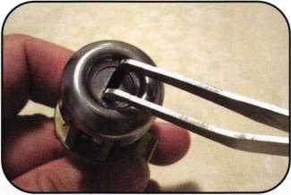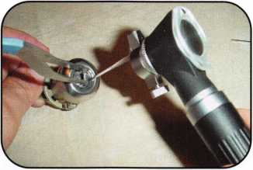

Photo 13

Photo 14

Photo 15

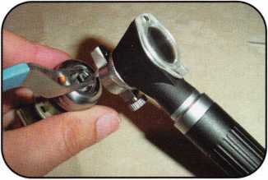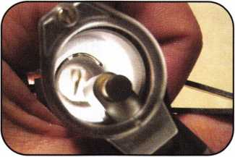

Photo 16

Keynotes • November 2002

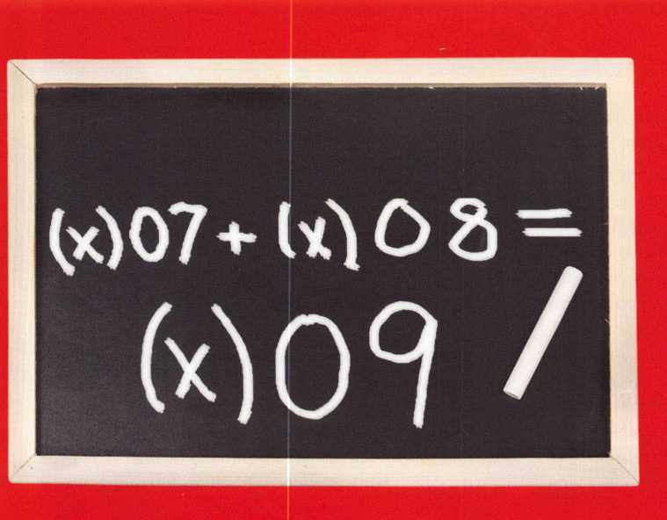

A New Old Lock (Almost)

By Greg Perry, CML, CPS

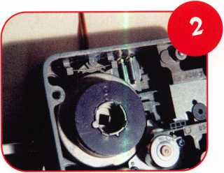

The Mas-Hamilton X-09 lock has arrived. It looks a lot like the X-08, while it operates like an X-07. There are some differences, but they seem minor.

The color is gray and some internal parts have changed. For those of you familiar with the X-07 and 8, this lock will seem like an old friend or enemy depending on how much you like them. The installa­tion instructions read almost word for word the same as the instructions for the X-08; the only difference is in the X-08, there is a plastic baffle that needs a couple of lines. Operation is just like the X-07.

Dialing left to the first number, pause; dial right to the second number, pause; dial left to the third num­ber, pause; dial right and the “OP” should appear, continue to stop.

Let’s look inside and install one on a container I had to drill open. I will provide an abbreviated installation instruction since the instructions that come with the

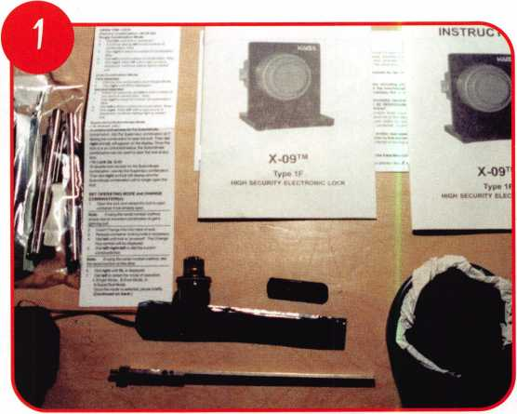

lock are very good. For this install, I will also use the new DRAT-08 or Dial Ring Alignment Tool from “Locks Unlimited.” A wrist strap is also needed any



Keynotes • November 2002

time you remove the back cover or work on any elec-  
tronic lock to prevent static discharge into the sensi-  
tive electronics.

To start this job, I drilled a Hamilton five drawer  
“Red label” container. Each drawer has its own lock  
and the combination to the top drawer was lost.

This container was in a secure  
building and they would not allow  
pictures of the opening, or the  
container. I drilled a quarter-inch  
hole for the lever fence 3/4-inches  
down and 7/8-inches left. Once  
inside the lock case, the tit or  
fence was drilled off, being careful  
to not to go too far. This allows  
you to pry the lever into the drive  
cam and retract the lock bolt  
using the spindle. Now it’s time to

repair the hole with a carbide plug welded both on  
the inside and out. The weld on the outside must be  
ground down and the repair hidden with auto body

spot putty. The surface must be textured to match the  
original finish and repainted to match. The repair  
specifications require that the repair not be visible to  
the naked eye including under the dial ring. With the

repair completed, it’s time for the  
new lock.

The lock and its components are  
as they come out of the box in  
photo 1. Removing the back cover  
of the lock in photo 2 reveals a  
lock body that looks very similar  
to the X-08, with the addition of  
a drive cam lock mechanism or  
“cam pawl” seen opposite the  
cover electrical connection. Photo

3 shows a close-up of the cam pawl engaged in the  
drive cam. This is used to lock the cam so the spindle  
nut may be loosened. A 5/16-inch nut driver is used to  
loosen the nut on the spindle of both the X-09 and  
the X-08. Starting the install, the DRAT-08 tool is  
used to measure the wall thickness. Since Hamilton  
file safes have raised mounting fasteners, the spacer  
plate seen in photo 4 is placed inside the container.  
The locking hub slides up to the face of the safe and  
is tightened down. Next, the shaft is unscrewed and  
reassembled outside the safe. This provides the cutoff  
fixture seen in photo 5 with the correct length set.

The tubes and spindle are cut on the fixture. If you  
do not have the DRAT-08 tool, the tubes may be  
measured and cut using the instructions that come  
with the lock. The cables and tubes are placed on the  
lock and inserted through the spindle hole. The lock  
case is screwed in place. The dial ring cover is

removed from the dial ring and set

aside as seen in photo 6. The dial  
ring is loosely screwed to the face  
of the safe. The DRAT-08 tool is  
attached to the dial ring with the  
thumbscrews. The shaft is inserted  
through the lock body and the nut is  
tightened down as seen in photos 7  
and 8. This sets the correct align-  
ment between the inner lock body  
and the dial ring. The dial ring  
screws are tightened and the DRAT-

08 tool is removed. The cables are routed and  
installed prior to installing the dial ring cover.

Moving to the back cover and spindle, seen in photo  
10, we see another difference from the X-08. The X-  
08 has a plastic baffle with an alignment pin to go  
through the back cover. The X-09 has this pin built  
into the spindle. The spindle is inserted through the

drive cam and the lock body. If you  
did not cut the spindle yet, place the  
hub on the spindle, mark the spindle,  
remove it and cut it at your mark.  
Replace the spindle through the drive  
cam and lock body. The dial hub is  
placed over the spindle, placing the  
dial hub-locating gauge between the  
hub and the dial ring cover. The hub  
screws are tightened down, the back  
cover is installed and the lock tested.

Once the lock has been tested several times, leave the  
bolt in the retracted state and remove the back cover.  
Install the locked-on back cover pin and reinstall the  
cover. Extend the bolt and seat the pin. Install the  
dial and retest the lock. The completed lock is seen in  
photos 11 and 12.

Now that the lock’s installed, let’s take a closer look  
around the inside of the lock. Starting with the cable,  
we see a screw on the plastic cover in photo 13. This  
allows for field replacement of the cable if it should  
be damaged, or if an extra thick container is encoun-  
tered. Photo 14 shows the bolt that (at least dimen-

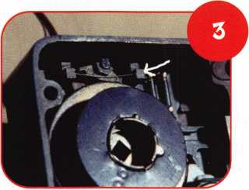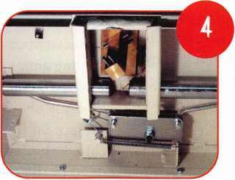

Keynotes • November 2002

**2**

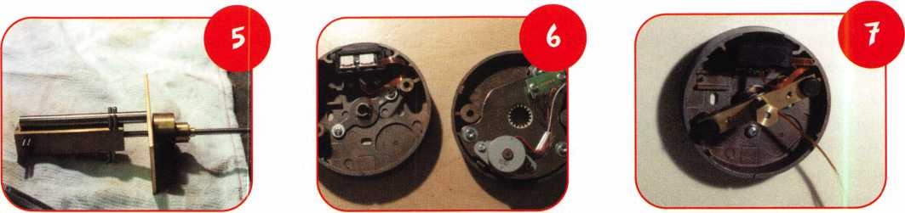

sionally) appears to be the same as the X-08. Photo 15 is a close up of the gears with the bolt retracted. Photo 16 has the bolt removed and the gears are back to the locked position; notice the two alignment dots on the gears. The gear beneath the motor is removed in photo 17; this exposes the area I would aim for if I needed to drill this lock. Joe Cortie, who used to work for Mas-Hamilton, suggested on the SAVTA web site ([www.savta.org](http://www.savta.org)) a different location. His target will work for all of the X-o series locks.

It is 1 5/16 -inches toward the bolt, then 1 3/16-inches right if VD or counter clockwise. This will put you on the outside edge of the motor gear. He uses a T30 Torx driver ground down to about 1/8-inches long to turn the gear. The last photo, number 18, is of the inside of the dial and the dial hub. This is one of the new features to the X-09. Inside the dial is a pentago­nal spring, which matches the hub. If too much turn­ing pressure is applied, this spring expands, allowing the dial to “clutch” or spin on the hub. The X-07 and X-08 have studs on the underside of the dial face to create the connection to the hub; this does not allow any clutch or slip.

The X-09 appears to be a nice mix of the X-07 and X-08. Returning the dialing sequence to left, right, left, right from the X-08 dialing is more natural for those who are used to dialing a mechanical lock.

The X-08 is dialed left to power, then right to the first number, pause, right to the second number, pause, right to the third number, pause, right to open. The SA lockout condition after 15 incorrect attempts is also gone. Instead, the X-09 *s back to working more like the X-07 — 10 errors, lock out for 3 min­utes. Different from the X-07 1S each consecutive incorrect attempt will initiate another 3-minute lock­out. After 15 incorrect attempts, the time is increased to 4 minutes. The X-07 has a 2-minute lockout after every 10 wrong attempts.

Since this is a first look at the X-09, I’m certain more will be written. The lock is too new to see problems. The one area I have a concern with is the plastic motor gear being used to retract the bolt. I feel the same way about the X-08. A bound, sticky bolt or end pressure on the lock bolt might allow a user to strip a gear tooth off the motor gear. The clutch mechanism added to the dial assembly should help alleviate the

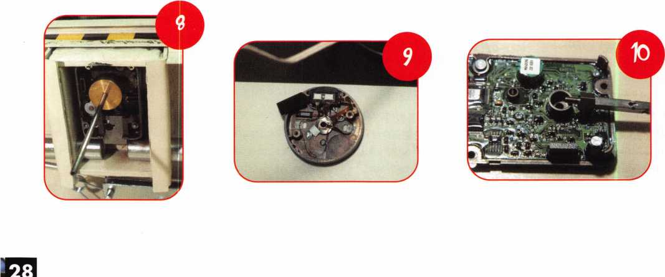

Keynotes • November 2002

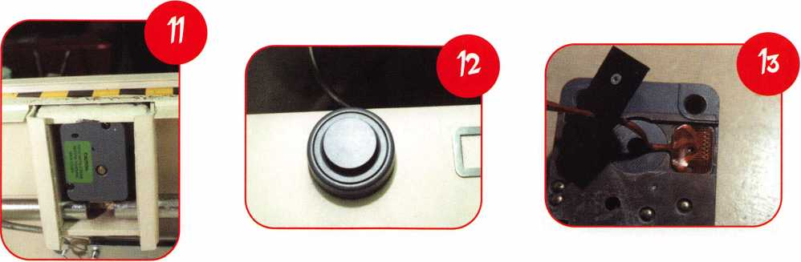

stripped gear teeth that caused some trouble in the X-08. Only time will tell whether this lock will be relatively problem free; if not, more will be written. Remember to always wear a wrist strap. The manufac­turers will tell you static electricity is their worst enemy, it is the cause of many failures.

Finally a few words about the DRAT-o8 tool. If you install these locks, you should consider purchasing one. Anytime you can use an alignment tool or tem­plate, your speed and accuracy are improved. It allows

you to charge the same amount for a job that will take less time, or give you fewer problems with an install that will make you money. Good tools don’t cost money; they help you make it. I’ve often heard others who speed up using better tools only to cut their fees to reflect their faster times and then wonder why they don’t seem to make more money Remember that bet­ter tools are an investment that needs to be paid for by keeping your rates the same. Next month, we will look at a cousin of the X-o series of locks, the Mas- Hamilton Cencon. See you soon. Q

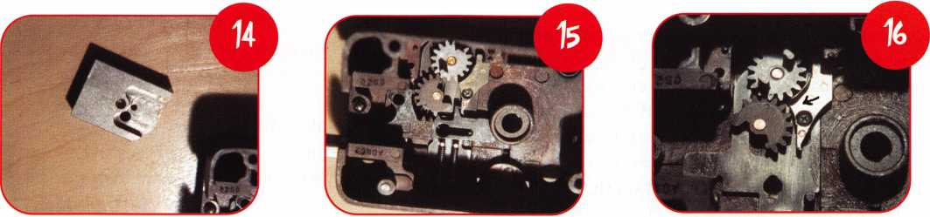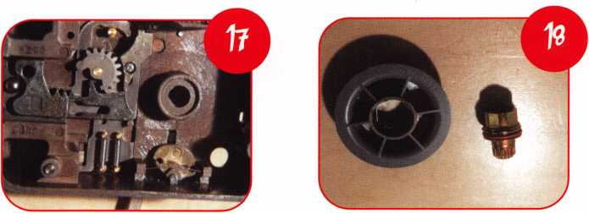

Keynotes • November 2002

ALOA’s PRP and Me

By Vernon Kelly, Institutional Locksmiths Association

If you spend any amount of time in the locksmith trade, you are bound to ask yourself if you should bother to earn the right to attach “a few extra letters” to the end of your name. There are quite a few associ­ations and organizations that have developed some sort of standardized test for their members (or for anyone in the industry with some extra time and money who feels knowledgeable enough to pursue certification). Here I will discuss the exam that I am (and most other locksmiths are) most familiar with - ALOA’s Proficiency Registration Program (PRP) - and some of my reasons for taking the exam.

For the uninitiated, the PRP is broken down into two groups of exams: a single mandatory exam, and 26 electives. The mandatory exam has about 250 questions, and covers the basic skills of locksmithing, such as basic master keying, key blank identification and opening techniques. The elective categories have 25 to 35 questions, depending on each exam, and include subjects like Life Safety Codes, safe opening and servicing, and advanced master keying. 'You must pass the mandatory exam and two electives to become a Certified Registered Locksmith (CRL). After that, you need another 12 electives to become a Certified Professional Locksmith (CPL), and then another nine to earn your Certified Master Locksmith (CML), which is the highest level of certification in the ALOA PRP. To become a Registered Locksmith (RL), you need to prove that you have a certain level of training and/or experience, but you are not tested.

Here are some of my reasons for taking the PRP (in no particular order):

• It is a good way to measure yourself against indus­try peers. Not so much in an “I know more than you know” way, but in a “This is what the industry thinks I should know” way.

* You’ll earn a little more respect. IVe had some salesmen completely change their attitude toward me (always for the better) once they found out I’m not just “the guy who sometimes fixes the locks.” Instead, after learning that I have a PRP designation, they know that I’m a skilled, experi­enced craftsman who has made an obvious com­mitment to the industry.
* And let’s face it: There are those in business who look down their noses at institutional lock­smiths. If the PRP can help alleviate that attitude, so be it.
* It looks good on a resume. You’re right: Outside of the locksmith industry, few people know what an RL, CRL, CPL or CML are. But once you explain to them that it is a voluntary program of exams and how difficult they are to pass, you will have a leg up on the other candidates applying for the job who don’t have a PRP designation.
* Here is another piece of information that you can divulge to your interviewer. I conducted a very informal and unscientific review of the 1999 ALOA Membership Directory looking for obvi­ous institutional workplace names, and here are the breakdowns on the number of institutional locksmiths with PRP designations that I found:

RL - 6 CRL - 42 CPL-9 CML -13

The numbers have surely grown some since then, but that means that in 1999, only 70 institutional lock­smiths in the world had a PRP designation. Let’s say that I grossly undercounted the number of institu­tional locksmiths who had a PRP title in my informal



Keynotes • November 2002

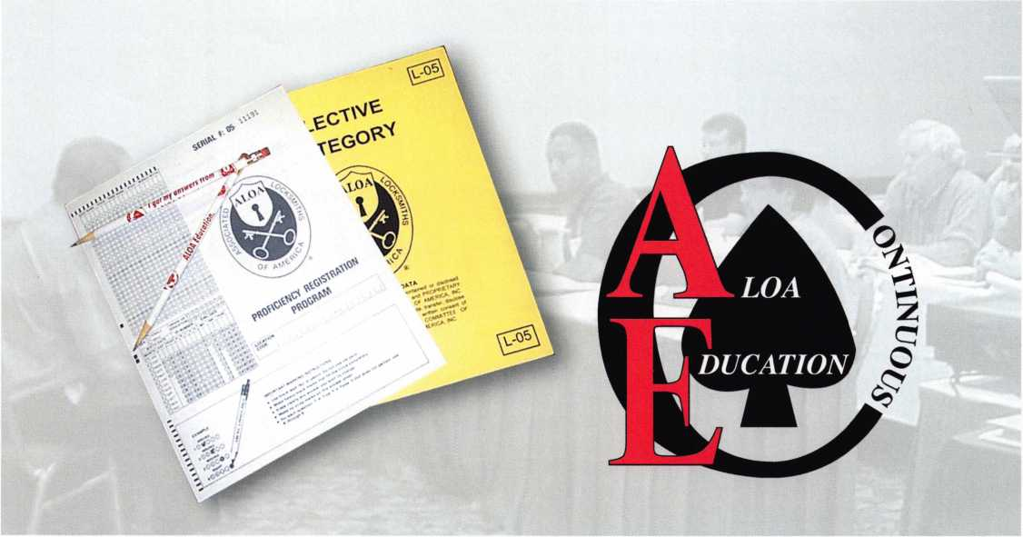

survey (I’m sure that I did), and multiply that number by five. That still means only 350 institutional lock­smiths had a PRP designation. Combined. In the world. Certainly, this is an elite group of institutional locksmiths, regardless of how casual my statistical analysis of the ALOA Directory was.

• It’s a wonderful way to challenge yourself to expand your knowledge about other locksmith techniques, products, nomenclature and life safety codes. For example, when I decided to try for the level of CPL, one of the electives that I (very non­chalantly) picked was Advanced Master Keying. After all, I had been a locksmith for nine years, took a two-day master keying class and had a cou­ple of really thick manuals on the subject. I thought that it would be a walk in the park, but my score on the test was a paltry 56 percent! Suffice it to say, I redoubled my efforts when studying for the next round of exams, and learned a lot more about master keying in the process. (And yes, I did pass it the second time around.)

• Finally, REVENGE! Even though most of the locksmiths I’ve had the pleasure to meet were very supportive and generous with the knowledge they were willing to impart to me, there were a select few who said, “You’ll never make in this line of work” or, “You’ll never be as good as Picky McPickset.” Revenge may not be the noblest of career motivators, but there is a certain guilty pleasure in proving your naysayers wrong. And it’s a powerful motivator, if nothing else.

In closing, don’t let my narrow view of the world stop you from thinking of your own reasons for taking the PRP. I’m sure that you can fine one or two reasons of your own. ALOA’s PRP may not be the “perfect” way to measure what a locksmith is sup­posed to know, and it does have its opponents, but I can honestly say that it has made me a better lock­smith. Plus, it has helped me to advance my career. Give it a try. You might just find out how much you don’t know - for now anyway! Q

Keynotes • November 2002

•Tv/itiyn ffiis aMJcrrsenes wiircfeaTwfflrtKe acVoT mMipulahng \Ke^i%reft'wfth7n the rdeR'cyfiiMer, to a$:coinpl.ishr'

s& I’kfak- tfecHHj»[ istess w*l$ vas^as'w©! jnfe?jhigi ^f^es1 ^t^olschseete*!:

^ \y^»i irasfe&t^grk,e^f€^^^^jafe>spiaaiicp*Sotwkf»^t®x4i^ ksii^iAkisii^tei^dtKWpi ipia tempers

§he?6(wt^aet^!HH®b fjfof)*arul almc

Mm ~ ‘ ’" ‘1 * and the tumblers within *+ rt' ** 1"" nS l^h

(apipruithniJiteKpi

**ft; tfae tlfetAifiiyiwid^F^teJrcji**

Ipty

Hbile the bottom pin Ls usu; ivor I

^etcay©dtti

ie*£tiwtii

■

B'i»v lotaroitfilfeix the

I /f #f«

m w1 ^tn^utei

to tiffin

,me !5p mnsTiiay withu^me upjWciaa;

Wtao^nWfe -mmfef ^

I tbateetilo&ke #fedftesi$t igl

*k$Mkt* wot

the sne.ar One analocK me plug, Wt «1

)Ptm56d «Fmd0?i«tspo»fetmitielt£.V

WeWMWIrM

itovdiar

:«?p¥$atete#1t>te tten:MB|«it«o|)Q's|ions

tip i vicinally \v

pins in the first

k cylinder and that it is possibleft)4now i ndi viduaffywhen %&have lifted

The Rake or Random Method

By Sal Dulcamara, CML

In the previous installment of this lock picking series, I dealt with the single pin method of picking pin tumbler locks. In this installment, I will occasionally make some references to some of the content and illustrations in part 2. If you have your July/August 2002 issue of Keynotes handy, you may want to keep it nearby while you read this. Your memory may suffice, but actually seeing what I refer to will probably be more beneficial.

I mentioned it then and repeat here that the single pin method is the most precise and scientific method of lock picking. You use your senses to feel the actual process of bringing a pin stack to a position where the split between top and bottom pins coincides with the shear line at the top surface of the lock cylinder plug. I made reference to two styles of single point contact picks- the hook and diamond tip styles. They are designed pri­marily for the single pin method of picking. Most brands of picks will include those two styles of picks. I will go into much more detail in an upcoming installment of this article series (on complications to various picking methods), but there are adjacent pin patterns in locks that will make your standard single point contact picks quite ineffective. It will depend on the sequence of pin chamber binding, but you will often have to lift a short pin that is further into the keyway and adjacent to a longer pin that is already picked. If the variation in pin length is minimal, the height difference between the neck of the pick and the contacting tip will allow the short pin to be lifted to the shear line without disturbing the longer pin already picked. At some length differ­ence, though, the picked longer pin will interfere with your ability to lift the shorter pin high enough. If you continue to lift the short pin, the handle of the pick will move the already picked longer pin and unpick it.

At that point, you will likely have to start all over again to pick that lock.

In an article printed last month (Peterson Picks), there are two hybrid single point contact picks, the Peterson Gem and the Peterson Reach, that will allow for a much larger pin length differential for adjacent pins. While even those picks will have their limit for length of adjacent pins, they will be more versatile with the single pin method than your run of the mill hook and diamond tip picks.

Keynotes • November 2002



The rake or random  
method of picking is  
nowhere near the preci-  
sion of the single pin  
method. The rake  
method has a much  
greater reliance on luck  
than the single pin  
method. I have to admit  
that as precise and scien-  
tific as the single pin  
method is, there will

always be some element

of luck when you are picking a lock. Someone with no picking skills may pick a lock by  
accident and it would be pure luck. But someone who can repeatedly pick a variety of  
decent quality locks has some kind of skill, whether or not that person is conscious of the  
technique being used. There are people with a natural talent for picking locks, although  
most of us have to practice to become proficient.

The same as when I teach a lock picking class, I purposely explained the single pin method  
before proceeding to the rake method. I did it for a very important reason. The rake  
method is much easier. On locks that are more vulnerable to manipulation, the rake  
method is almost always faster and easier. On many tougher locks, the rake method is less  
effective. That is when the precision and skill required of the single pin method will pay  
off. I know it is human nature to be a bit lazy and try the easy route first. Often if you learn  
the rake method first, you lack the patience to stick with practicing the more difficult and  
precise single pin method. If you are seeing this installment (part 3) before the previous  
installments, I suggest studying and practicing the single pin method first. If you don’t,

I would hope that you go back to it later and give it an honest try.

The rake method of picking is generally accomplished with multi-point contact picks.

They come in a variety of shapes and configurations and are often generically identified as  
a family of picks just as “rake” picks. Individual pick manufacturers will often give different  
names to the various multi-point patterns, so they are not always uniformly identified. Two

such patterns are shown in figure 1. I will use  
the names given to the Peterson picks shown

in an article elsewhere in this issue, just  
because you can view the pictures right  
away to compare them to the  
drawings. Most manufacturers  
of lock picks, though,  
make something resem-

bling either pick style.  
The Peterson pick name  
for the top style is the  
Double Rake. The pick  
at the bottom would be  
called the Long Ripple.  
Both of these picks

operate a bit differently within a lock,  
as I will explain a bit later in this article.

Something that I didn’t emphasize much in part 2 and that I won’t overly explain here, is the use of turning tools (also called tension wrenches, among other names). The placement of a turning tool into a keyway will affect the movement and operation of a pick within the lock’s keyway. If you

Keynotes • November 2002

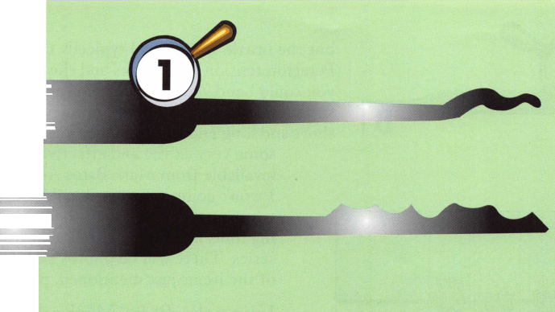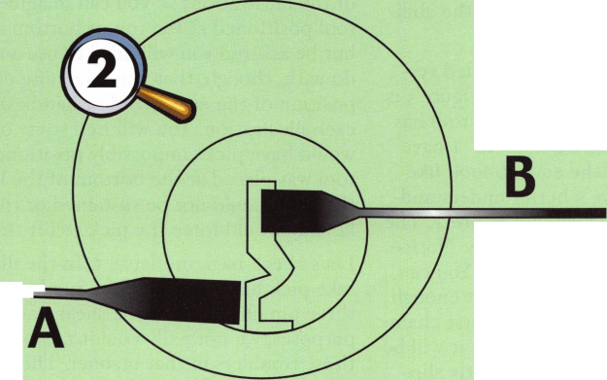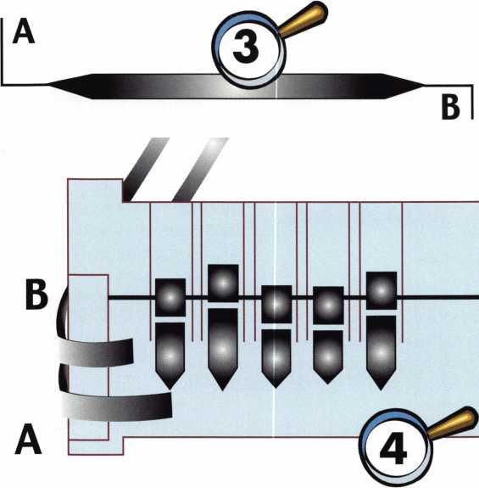

have one or more fairly long bottom pin in a lock, you will need to lower your pick far enough in the keyway to avoid raising any long pins so high as to block the shear line. You will almost never know the arrange­ment of pins in a lock before you begin to pick, so it is something you can’t typically predict. As long as just one pin blocks the shear line, you will not be able to pick the lock. It doesn’t matter that the remaining four (or five on a six pin lock) are at the shear line.

In figure 2, letter A identifies the more common placement of a turning tool at the bottom of a keyway for picking a lock. Letter B shows a variation for plac­ing the turning tool at the top, to give picks the abili­ty to drop lower in the keyway for long pins.

In some of my lock pick sets, I keep a modified ver­sion of an HPC double ended turning tool. Figure 3 is my version of the tool. Typically the original tool has both ends that resemble the end labeled ‘A.” I have taken to grinding down one of the ends to look like the end labeled “B.” You’ll have a better understand­ing of my reasoning when you check out figure 4. The ‘A” end is shown in the bottom of the keyway. Notice how far it typically extends into the keyway. You can see the shortened “B” end of the tool is short enough not to hit and interfere with the pin in the first cham­ber. You could try the ‘A” end at the top, but it will be very difficult to seat cleanly without constantly slip­ping out.

but the brittle spring steel typically cracks. With the Peterson tension tool blanks and the bending tool, you could bend your own custom turning tools for the situation at hand. LAB makes some very interesting short and long end turning tools, and John Falle has some very exotic and effective turning tools (available from Mark Bates Associates/ MBA).

I won’t go into further detail here, since I will cover turning tools and other specialized pick­ing tools in a future installment of this article series. There will be photos and descriptions of the items just mentioned, plus a lot more.

Using the Rake Method

Figure 5 will give you some impression of what a multi-point contact pick like the double rake can do with tumblers within the keyway. The various contours of the pick are able to posi­tion more than one tumbler (of different lengths) to the shear line at the same time.

By moving or tilting the pick we can make other groups of pins arrive at the shear line.

At the same time, the pins that were at the shear line will also shift elsewhere.

Figure 5 and the next few illustrations will show a pick in the keyway without a turning tool. We know that a lock can only be picked that way on TV or in the movies. We still have to follow the basic princi­ples of lock picking explained in part 1 for the rake method. We will need a turning tool, and unless we can manage to raise all the pins to the shear line simultaneously, we will have to be able to bind pins in a picked position while we attend to pins that have not yet been picked. I’m leaving the turning tool out of the illustrations so you can imagine either a turning tool positioned at the top or bottom of the keyway, but be assured you will need to use a turning tool. I do wish, though, that you take note of the angle and position of the necks (and/or handles) of the picks in each illustration. You will find some of them that would have picks impossibly positioned if the turning tool was placed at the bottom of the keyway Either the angle could not be sustained or the height in the keyway would force the pick to lift the pins higher.

Let’s check back on figure 5. In the illustration, the rake pick has positioned the tumblers in the middle three pin chambers at the shear line. For all practical purposes, we normally couldn’t knowingly position those tumblers in that manner. The tumblers could be positioned that way, but it would be random and accidental.

I have tried just bending the straight end of a single ended turning tool to have a short extension piece,

Keynotes • November 2002

For the sake of argument, we will pretend that we could knowingly position those tumblers as shown. Now let’s engage our turning tool. Remember, the turning tool is not shown here (and won’t be shown in the later illustrations), but you will position it at the bottom or top of the keyway using side A or B of our turning tool. We apply slight rotational force, and we could choose to go either clockwise or counterclock­wise. The results will typically be different going in opposite directions. We then lower our pick in the keyway. What follows will depend on the sequence of binding for the pin chambers.

I will set up a few hypothetical chamber binding sequences. Each lock will typically have one binding sequence for clockwise, and a different binding sequence for counterclockwise. My first chamber binding sequence (CBS) will be CW-51243, and my second will be CCW-34215. My shorthand indicates CCW for counterclockwise rotation and CW for clockwise rotation. The numbers identify the order (bow to tip from a key reference) from the face of the lock inward, which chambers bind in what sequence. CW-51243 indicates that when rotating clockwise, the pins in chamber 5 bind first, followed in order by the pins in chambers 1, 2, 4 and 3. The other chamber binding sequences will translate in the same manner as I have just described. If you are reading part 3 before the other installments, you may need to go back to parts 2 or 1 for an explanation of how and why pins bind in a chamber.

Here is what would happen with a chamber bind­ing sequence of CW-51243 for the pins positioned in figure 5. When clockwise rotation is applied, chamber 5 would bind first. That means that the plug would rotate slightly and the top pin of the fifth chamber would be bound at the shear line between the right side wall of the top chamber and left side wall of the bottom chamber. All rota­tional motion would stop before any more pins could bind. That would occur because the split point between the top and bottom pins of that chamber is not currently positioned at the shear line. Once the pick was lowered in the keyway, all the remaining four pin stacks (currently being lifted by the pick) would drop from the tumbler spring pres­sure. Tumbler springs have not been drawn in the illustrations, but presume that they would be there. Since the pick wasn’t far enough into the lock to even make contact with the fifth bottom pin, the one chamber that bound didn’t even prevent the end result of all the pin stacks settling to the bottom.

Now let’s review what would occur if the chamber binding sequence was instead CCW-34215. We are still referring to the pin arrangement and pick positioning found in figure 5. When counterclockwise rotation is applied, chamber 3 would bind first. Since the split point of that pin stack is at the shear line, the plug would continue to rotate. The next position to bind would be chamber 4. Since that chamber is also at the shear line, the plug would rotate further. Chamber 2 is the next to bind, but it is also at the shear line. The plug would continue to rotate. It would abruptly stop when the top pin in chamber 1 got trapped between the left side wall of the top chamber and the right side wall of the bottom chamber. This would occur since chamber 1 was the next to bind and the split of the pin stack was not at the shear line. As long as you maintained rotational force, lowering the pick would allow the bottom pins in chambers 1, 2, 3 and 4 to drop. However, the top pins in chambers 2, 3 and 4 would remain in the top chamber and those three chambers would stay picked. The top pin in chamber 1 would remain bound and suspended while straddling the shear line, even though the bottom pin below it would drop without the pick to hold it up. There would be a measurable gap between the top and bottom pins in chamber 1, but that chamber would not yet be picked as long as the top pin blocked the shear line.

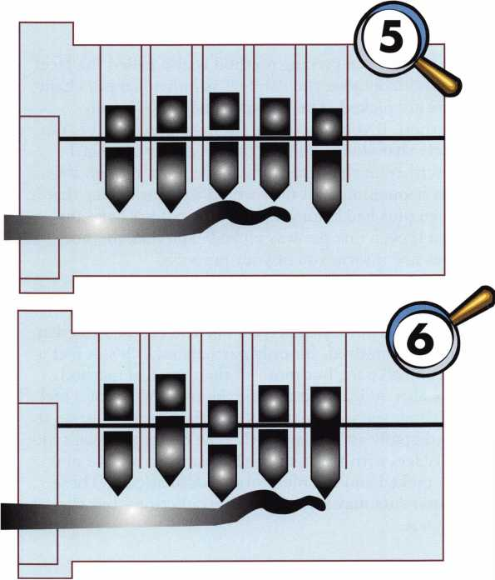

Keynotes • November 2002

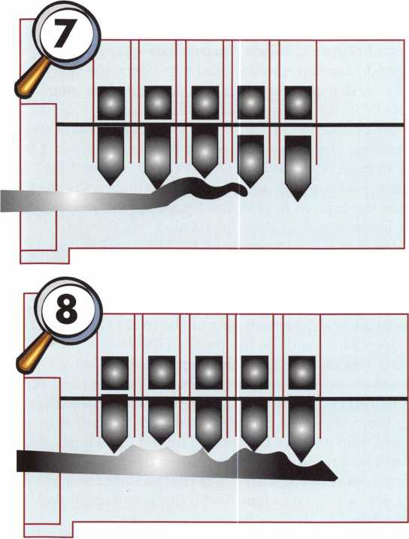

The single pin picking method is also called the “feel” method, because you can feel as individual pin cham­bers are picked. The rake method is not a feel method. If you were using the rake method, it is not likely that you would feel or detect any of what I described in the paragraph above, even though that was happening. Not only would you not detect that three pins had been picked, you wouldn’t have any idea if even one pin was picked. The rake method does not inform you of your progress.

I’ve indicated earlier that the rake method has a greater reliance on luck than the single pin or feel method. That remains true, but you can be skilled at the rake method. It’s only partially luck. It’s in fact a very small part, but more so than the feel method.

I’ve also indicated that the rake method is not a feel method, yet you must have the right “touch” to do it predictably and consistently The only thing you typi­cally feel with the rake method is when all five pins are picked and the plug rotates dramatically. These statements may sound like contradictions, but they are not.

I have not yet described the method or procedure of rake picking. I’ve waited this long partly so that you could understand what is going on inside the lock first and also because the description of the process is short, sweet and simple, but the actual process is not usually quite as simple. This is the rake method:

Position your turning tool in the keyway for rotation. Take a rake pick and insert into the keyway. Move randomly in and out of the keyway and up and down to vary pin heights. Make sure you contact all the pins from the front to the back since a lock will only open if all pins are picked. Maintain light but consistent turning pressure with your turning tool and keep on manipulating and moving the tumblers until the plug rotates to unlock the lock. A little too simple, isn’t it?

On certain poor quality locks with extremely sloppy manufacturing tolerances and containing bottom pins with a very narrow range of pin lengths, a rank ama­teur with virtually no skill could pull it off. The luck that allows it is not just that the amateur has the luck to position all the tumblers in the right place for the shear line. The other element of luck is confronting a lock in that condition. By that condition, I mean a lock that is just begging to be picked open, and offers virtually no resistance. Very few locks (as a percent of all locks) will fall into that category, but many will come close to it.

Locks with tighter tolerances and a greater length variation range for adjacent bottom pins will put up a tougher fight against the potential lock picker. Oftentimes, only the most skilled (read that as having the right “touch”) rake pickers will open those locks with this method. To reinforce your knowledge, I will use some illustrations to explain what might go on in a lock while you are rake picking and what you will likely detect.

The examples in figures 6 and 7 will coincide with the same chamber binding sequence of CW-54132. In fig­ure 6, I will start with my turning tool at the top of the keyway (not illustrated) to anticipate the possibili­ty of long bottom pins. Applying very light turning pressure, I will move the rake pick inward as I also move it up and down within the keyway to vary the height positions of the pin stacks. During the random movement, individual pin stacks will find the shear line and shift from it, since the chambers are not in the correct binding sequence. When the binding sequence of a chamber coincides with the pin stack within it at the shear line, that chamber will pick. When it occurs, we will typically not detect it. When the pick is positioned as it is in figure 6, we find that pin chambers 5, 4 and 1 are in the correct binding sequence while being at the shear line. The light turn-

Keynotes • November 2002

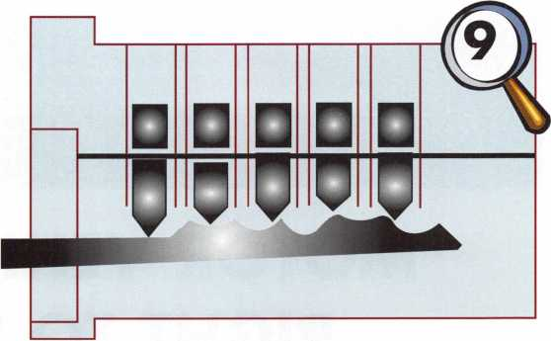

ing pressure will take advantage of this condition and the plug will rotate slightly but we will not detect the slight movement. As we move the pick backward to the position shown in figure 7, the bottom pins in chambers 4 and 5 drop to the bottom of the chambers while the top pins remain suspended at the shear line. The top pin in chamber 1 is also suspended, but the neck of the rake pick keeps the bottom pin upward and in contact with the top pin. The repositioning of the pick now causes the pin stacks in chambers 2 and 3 to line up at the shear line. The light turning pres­sure of the turning tool rotates the plug and the lock is picked.

What I just described could take place with five dif­ferent locksmiths trying to pick the same lock, with one locksmith succeeding in fifteen seconds and one in twenty minutes, and the remaining three ranging between the two extremes. They could pick it all in the exact same sequence, but the length of time between one action following another could vary dra­matically Even though it is not the single pin method, it is possible to use the rake method and have all five pins pick one at a time in sequence. The difference with the rake method is that you are not trying to feel individual tumblers pick, so you don’t have any real sensation as to what occurred until the last pin is picked. For all you know, when taking 20 minutes to pick a lock, the first three pins could have been picked in fifteen seconds, the fourth a minute later, and you unwittingly end up fumbling with the last solitary pin for more than 18 minutes all by itself.

You could just as easily spend 19 minutes with not even one pin picked and pick all five in the last minute. That goes with the territory for rake picking, but the more practiced and proficient you are, the quicker and more consistent you will be when using the method.

The last two examples I will explain are with the Long Ripple pick in figures 8 and 9. The Long Ripple and picks of its type have long pattern profiles and can often manipulate all five tumblers at the same time. In these cases, you don’t necessarily make use of or need the ability to bind pins for picking. If you can somehow raise all pin stacks to the shear line simulta­neously, it will not matter the chamber binding sequence. The maneuvering process in the keyway is similar to the rake pick, but it is sometimes a good idea to fully insert the pick to make sure all pins are in contact. The method will sometime simulate the operation of a key except that with repositioning and tilted angles, you can simulate dozens if not hundreds of possible key cut configurations.

Figures 8 and 9 show the same configuration pick with two different locks that contain a completely dif­ferent pin arrangement. With different pins touching different spots of the pick and the pick either further in or out or up or down, you get the net result of a different simulated key pattern. When using the Long Ripple or similar picks, you don’t necessarily always pick five pins simultaneously. In fact, you probably rarely do. But since you are not using a “feel” method you only know when the plug turns and the lock is picked. You can rarely be sure if you are picking the pins in groups or all at once.

It is difficult to explain “light touch” to someone who has never picked a lock. When I teach a class, I can never be sure how much pressure an individual student is applying with his or her turning tool. When I see the tool with a severe bend, though, I can tell they are applying way too much pressure. It is something that must be practiced and experimented with. If you have difficulty with this method, try the crutch I explained in part 2. Just remove some of the tumblers to simulate a 4, 3 or 2 pin lock, and try then. Hopefully, you don’t have to go back to two pins, since it would almost be effortless (providing you don’t use extreme length dif­ferences for adjacent pins).

The illustrations that I refer to (from part 2 in the September 2002 issue) were originally rough sketches that I drew. The Keynotes graphics department recre­ates them, and on occasion they don’t translate exact­ly the same. If I describe a characteristic in the text here and the graphic looks a bit different, try to imagine it as I describe it. If something doesn’t make sense or look right, you can go to my web site at <http://home.earthlink.net/dockwriter> and go to the Tech Article Addendum link. If I caught it, I may describe there what you should have seen. If I didn’t, there is an e-mail link, and you can notify me so that I can make a clarification or correction. Watch for part four in this series soon. Q

Keynotes • November 2002

**3**



MOTOR VEHICLE OWNER'S  
RIGHT TO REPAIR ACT  
IN GRAVE JEOPARDY!!!

**CALL SENATOR DORGAN AND OTHERS TODAY AND LET THEM KNOW LOCKSMITHS  
DO NOT ACCEPT DEAL OFFERED BY AUTOMOBILE MANUFACTURERS!!!**

A clandestine deal that has damaging effects on lock­smiths was reached recently between the Alliance of Automobile Manufacturers, the Association of International Automobile Manufacturers and the Automotive Service Association. The ASA broke ranks with the Coalition for Auto Repair Equality (CARE), of which ALOA is a member, and cut a horrible deal with the auto manufacturers that will keep locksmiths from important service information.

The agreement reads, "Automobile manufacturers hereby commit to make available, by August 31,

2003 emission and non-emission related service infor­mation, training information, and diagnostic tools in the same manner and to the same extent as specified by California Air Resources Board (CARB) regulations for emission-related systems and components."

The CARB regulations ONLY apply to "covered per­sons" which is defined ONLY as "auto-repair facili­ties"! This means that locksmiths are OUT!!

Worst yet: the ASA and the automobile manufacturers maintain there is now no need for S. 2617 or H.R. 2735, the "Motor Vehicle Owner's Right to Repair Act" to move forward.

**THEY ARE WRONG!!**

**CALL OR FAX SENATORS DORGAN AND WELLSTONE TODAY!!**

Tell them this deal shuts out locksmiths who need information to better service their customers. Tell them this horrible compromise was made without con­sulting or getting approval from CARE. Tell them the agreement does not include any enhanced tools and has no enforcement behind it!

Sen. Dorgan

(Senate Sub-Committee Chair) 713 Hart Senate Ofc. Bldg. Washington, DC 20510 202-224-2551 (phone) 202-224-1193 (fax)

Sen. Paul Wellstone (S. 2617 Sponsor)

136 Hart Senate Ofc. Bldg. Washington, DC 20510 202-224-5641 (phone) 202-224-8438 (fax)

**CALL OR FAX  
REPRESENTATIVES  
BARTON AND TOWNS  
AND STILL DEMAND A  
HEARING IN THE HOUSE!!!**

Rep. Joe Barton  
(H.R. 2735 Sponsor)

2264 Rayburn House Ofc. Bldg.  
Washington, DC 20515  
202-225-2002 (phone)  
202-225-3052 (fax)

Rep. Edolphus Towns  
(H.R. 2735 Sponsor)

2232 Rayburn House Ofc. Bldg.  
Washington, DC 20515  
202-225-5936 (phone)  
202-225-1018 (fax)

CHECK OUT ALOA'S WEBSITE AT <http://www.aloa.org/news/legcom.cfm>  
FOR THE LATEST HAPPENINGS IN YOUR STATE

Keynotes • November 2002

New Year Brings New Age for North Carolina Locksmiths

by Laura J. Busse, CRL; Chair, NC Locksmith Licensing Board

After years of lobbying and negotiation, the North Carolina Locksmith Licensing Act was signed into law in August 2001. The law goes into full effect on January 1, 2003. Anyone performing locksmith and safe technician services in North Carolina after that is required to have a license.

Licenses are not issued to companies, but to individ­uals. Employees are exempted only as long as they work under the direct supervision of a licensed lock­smith. In the end, each person performing work unsupervised must obtain his or her own license. Failure to comply is a misdemeanor. In order to obtain a license, applicants must:

1. be at least 1 8 years of age;
2. pay the required fee ($100 for 3 years);
3. be of good moral and ethical character;
4. either pass an examination administered by the Board or qualify under the statute's "grandfather clause."

Items 1 and 2 are simple enough. Interpreting and applying items 3 and 4, on the other hand, is left to the NC Locksmith Licensing Board which was creat­ed by the statute (in consultation with the State's attorneys, of course).

The Board essentially relies on criminal records to determine applicants' moral fitness for licensure. Only the most serious crimes permanently disqualify a person from licensure.

Generally, criminal convictions are categorized by number and seriousness. The more numerous or seri­ous the crimes, the longer the period of disqualifica­tion. The Board also has the latitude to

consider additional factors in determining a person's eligibility for a license, such as the relevance of the crime to the duties of a locksmith and the age of the person when he or she committed the crime(s).

The "grandfather clause" remains in effect until Dec. 31, 2003. It allows applicants who can submit proof of at least 2 consecutive years active engage­ment in the trade in NC prior to the effective date to qualify for a license without taking the examination. The application package explains what sorts of proof to submit; both owners and employees can qualify for licensure under this provision.

The examination consists of a subset of ALOA's PRP examination, plus a section which tests applicants' comprehension of their obligations under North Carolina law, such as the ethical code established by the Board.

Applications, as well as the complete text of the statute and rules, are available on-line at

[www.nclocksmithboard.org](http://www.nclocksmithboard.org) or by contacting the NCLLB at P.O. Box 10572, Raleigh NC 27605; phone: 919-838-8782; fax: 919-833-5743. Be sure to select the application for "Section 2" if you think you might qualify under the "grandfather clause." Select the regular application if you will need to take the test. Hurry! The deadline is coming up quickly!

Note: The information provided here is only a summary and is NOT a substitute for reading the statute and rules in their entirety.

Keynotes • November 2002

EMPLOYMENT

LOCKSMITH, FULL TIME POSITION.

Southern California location, commercial/industrial work, no automotive. Earn $2,400 - 3,520 per month plus benefits. Minimum 2 years experience and clean DMV. We are a professional company specializing in commercial and industrial security. We also sell, install and service, CCTV, access con­trol, and monitored alarm systems. Please contact Dan or Curt @ 714-632-5558.

LOCKSMITH WANTED

Busy shop in Woburn, MA, has immediate opening for a self-motivated, reliable locksmith. Large cus­tomer databases for automotive, AAA, commercial and residential accounts. Applicants with own van and tools are guaranteed 50 percent commission. We can also supply van and tools. A great oppor­tunity for the right individual. All inquiries are kept strictly confidential. Send resume to: Locks & Keys Inc. P.O. Box 222, Woburn, MA, 01 801.

E-mail: [jobs@locks-keys.com](mailto:jobs@locks-keys.com). Or call John at 781/933-9999.

EXPERIENCED TECHNICIAN WANTED

Residential/Commercial/Experienced Automotive locksmith wanted. Rapidly growing, well-estab­lished Houston firm looking for good men capable of handling all types of lock work. Must have own tools and transportation. Excellent pay and other benefits provided. Apply at 281/497-5555 or FAX 713/975-7534.

COMPANY IN SEARCH OF A LOCKSMITH

with a Top Secret security clearance with experi­ence in X07/X08 systems. This is a immediate opening in the Northern Virginia area with a salary of $45-50K and a comprehensive benefit package. Interested candidates should e-mail resume and cover letter as an MS Word attach­ment to Michael W. Banks • Executive Vice President & COO • ZKD Inc. • office 703-243- 8744 fax 703-243-7747 • cell 240-216-4728 [www.zkdinc.com](http://www.zkdinc.com)

Classified Advertising Policy

Classified advertising space is provided free of charge to AiOA members, and for a fee of $.60 per word, $15 minimum for non-members. Classified ads may be used to advertise  
used merchandise and overstocked items for sale, "wanted to buy" items, business opportunities, employment opportunities/positions wanted and the like. Members or non-members wishing  
to advertise services or new merchandise for sale may purchase a "Commercial Classified Ad," for a fee of $1.30 per word, with a minimum of $40. Each ad will run for two issues. For blind  
boxes there is a $5 charge to members and non-members. All ads must be submitted in writing to the ALOA office by the fifteenth of the month, two months prior to issue date. Send to  
Keynotes Classifieds, 3003 Live Oak St, Dallas TX 75204-6186. ALOA reserves the right to refuse any classified advertisement that it deems inappropriate according to the stated purpose

of the classified advertising section.

Keynotes • November 2002



LOOKING FOR A CHANGE?

We are currently looking for a Shop Manger. Duties include running daily operations, scheduling, dispatching, hiring and training. We're also looking for experienced Road Techs and Apprentices. We are a growing company and we are looking for individuals with a positive attitude and good work ethic. We take pride in our employees and they are compensated well. We offer a complete benefits pack­age, including 401 (k). If this looks like something you may be interested in, send or fax your resume to:

McCausland Lock and Alarm 1101 Lincoln Ave. • Prospect Park, PA 19076 Phone: 610/522-1935 • Fax: 610/532-8173 e-mail: maclOl [l@aol.com](mailto:l@aol.com) • Attn: Tom McCausland

LOCKSMITH WANTED

Relocate to Houston. Knowledgeable Locksmiths earn $3,000 per month. Call 281/830-9441.

ACCOUNT EXECUTIVE WANTED

We are seeking an energetic, experienced sales profession-, al to join our rapidly growing team. Candidate must pos­sess a strong background in commercial hardware as well as electronic access control, (CCTV and alarm experience is a plus!). Minimum 5 years sales experience required. We offer: Top wages, commission, expense account, 401 (k), paid vacations and holiday, hospitalization.

E-MAIL resume to: [rmesnick@bass-security.com](mailto:rmesnick@bass-security.com) <[mailto:rmes- nick@bass-security.com](mailto:rmes-nick@bass-security.com)> or phone-216-755-1200 ext#128.

STOP LOOKING!!!!!

EXPERIENCED TECHNICIANS WANTED

Lock into your future now!

If you are experienced, intelligent, and desire a secure future, come join our team. We are a full service commercial/residential security service (locks,keys,safes,cctv,access control, door related hardware). We offer: sign on bonus, top wages, company vehicle, 401k, paid vacation, paid holidays, new uniforms, cross training, and job satisfaction.

We are looking for the best tech's, who are ready to be treated and compensated as professionals.

Bass Security Services, Inc.

Ph#216-755-1200 ex.# 128

Fax#216-755-1220

E-MAIL / [rmesnick@bass-security.com](mailto:rmesnick@bass-security.com)

BUSINESS FOR SALE

BUSINESS FOR SALE

Well-established locksmith business in California. Grosses $140K per year. Priced at $75K. No outstanding loans on business. 80 percent income from existing accounts.

Included in price: well-maintained 94 F250 Locksmith van,

equipment to work out of both vans, plus furnish a separate work area and lots and lots of stock. FAX 949/458-1733 for an immediate response from us, or call Keynotes classi­fieds at 800/532-2562, ext. 19, and leave your informa­tion so we can contact you. Thanks.

FOR SALE:

Mobile lock shop equipped with $4000. Write or call Anthony Rossi, 45055 East Florida Ave., Hemet, CA, 92544. Phone 909/927-6858.

WORK WANTED

SECURITY PRO FOR HIRE

CML, CPS seeks a challenging and personally rewarding position as a Locksmith at the supervisor or management level. Would prefer institution or college in the Midwest or central United States, however all locations would be con­sidered. 30+ years in the field and well versed in all aspects of sales, training and management. Please respond to the editor of ALOA, (800)532-2562, ext. 19.

WANTED TO BUY/SELL

FOR SALE:

Locksmith tools, code books, hardware, key blanks. Framon, Curtis, Aero, Schlage, LSDA. For complete list, contact Gary at P.O. Box 52, Conover, Wl, 54519, phone 330/418- 1689 or e-mail: [gary@cybertekweb.com](mailto:gary@cybertekweb.com), view complete list on web at [www.cybertekweb.com/tools](http://www.cybertekweb.com/tools).

CURTIS #14A CODE CUTTER CARRIAGES:

Ford 2, Chry3, AM2, Ford 3, Chry2, DC1, AMI, DM30, Chryl, Toy4, HD9A, Toy3, Toy2, Dyl, DMN, HD4A, GM2, GM1, HD4B, Toyl, GM2X. Cams: GM1, Chryl, Chry2, Ford3, Ford 1, Ford 2. Key gauges: GM, Ford, Chrysler, AMC, Toyota. Curtis Code books for older model: GM 1935-82, Honda Nissan, Mazda, Ford 5-pin and 10 cut, AMC, Chrysler. $400, shipping included. Call Precision Lock Service at 330/41 8-1689, or e-mail to: [gary@cybertekweb.com](mailto:gary@cybertekweb.com).

FOR SALE

Abloy Key machines for sale. One brown, one blue. Also, misc. Abloy cyl., Abloy keys, Abloy parts. Medeco Sky II and Standard deadbolt, knob cyl., and misc. Make offers, whole or part. Call 561/746-6404.

WANTED TO BUY

Wanted: Original Hurd and Briggs & Stratton auto key blanks. I will pay $1 each. Send me a list of what you have. Write to: Douglas Vogel, 4779 Meadowlark Ln., Dexter, Ml, 48130.

**41**

Keynotes • November 2002



Distributor

ADI Inc

Phone: 631-692-1000 Fax: 631-692-3011

Accredited Lock Supply Co

Phone: 201-865-5015 Fax: 201-865-0030 [www.acclock.com](http://www.acclock.com)

Ace Lock & Security Supply

Phone: 908-688-7666 Fax: 908-688-2442 [www.acelock.com](http://www.acelock.com)

Action Hardware Inc

Phone: 800-662-6695 Fax: 800-930-2329

Andrews Wholesale Lock Supply

Phone: 717-272-7422 Fax: 717-274-8659 [www.andrewslock.com](http://www.andrewslock.com)

Boyle & Chase Inc

Phone: 800-325-2530 Fax: 800-205-3500 [www.boyleandchase.com](http://www.boyleandchase.com)

Clark Security Products

Phone: 800-854-2088 Fax: 619-974-5284 [www.clarksecurity.com](http://www.clarksecurity.com)

Cook's Building Specialties

Phone: 505-883-5701 Fax: 505-883-5704

Dire's Lock & Key Company

Phone: 303-294-0176 Fax: 303-294-0198

Direct Security Supply, Inc.

Phone: 800-252-5757 Fax: 800-452-8600

Doyle Security Products

Phone: 800-333-6953 Fax: 612-521-0166 [www.doylesecurity.com](http://www.doylesecurity.com)

Dugmore and Duncan, Inc.

Phone: 888-384-6673 Fax: 888-329-3846

E. L. Reinhardt Co., Inc.

Phone: 800-328-1311 Fax: 651-481-0166 [www.elreinhardt.com](http://www.elreinhardt.com)

Ewert Wholesale Hardware

Phone: 800-451-0200 Fax: 708-597-0881

Fairway Supply, Inc.

Phone: 214-350-0021 Fax: 214-352-4299 [www.fairwaysupply.com](http://www.fairwaysupply.com)

Foley-Belsaw Company

Phone: 800-821-3452 Fax: 816-483-5010 [www.foley-belsaw.com](http://www.foley-belsaw.com)

Fried Brothers Inc.

Phone: 800-523-2924 Fax: 215-592-1255 [www.fbisecurity.com](http://www.fbisecurity.com)

H L Flake Co

Phone: 800-231-4105 Fax: 713-926-3399 [www.hlflake.com](http://www.hlflake.com)

H.S. & S. Wholesale Distrib.

Phone: 313-342-6777 Fax: 313-342-7580

Hans Johnsen Company

Phone: 214-879-1550 Fax: 214-879-1530 [www.hjc.com](http://www.hjc.com)

Hardware Agencies, Ltd.

Phone: 416-462-1921 [www.hardwareagencies.com](http://www.hardwareagencies.com)

Howard Keys

Phone: 704-509-4944 Fax: 704-509-6248 www. howa rd keys .com

IDN Incorporated

Phone: 817-421-5470 Fax: 817-421-5468 [www.idn-inc.com](http://www.idn-inc.com)

Intermountain Lock & Supply

Phone: 800-453-5386 Fax: 801-485-7205 [www.intermountainlock.com](http://www.intermountainlock.com)

Jo Van Distributors

Phone: 416-752-2238 Fax: 416-752-7282 [www.jovanlock.com](http://www.jovanlock.com)

Lockmasters, Inc.

Phone: 859-885-6041 Fax: 859-885-7093 [www.lockmasters.com](http://www.lockmasters.com)

Locks Company

Phone: 800-288-0801 Fax: 305-949-3619

Locksmith Ledger International

Phone: 770-886-0800 Fax: 770-889-7703 [www.lledger.com](http://www.lledger.com)

M. Zion Company

Phone: 212-349-8677 Fax: 212-964-0495 [www.mzion.com](http://www.mzion.com)

McDonald Dash Locksmith Supply

Phone: 800-238-7541 Fax: 901-366-0005 [www.mcdonalddash.com](http://www.mcdonalddash.com)

McManus Locksmith Supply, Inc.

Phone: 704-333-9112 Fax: 704-332-8664

Monaco Lock Co.

Phone: 800-526-6094 Fax: 800-845-5625 [www.monacolock.com](http://www.monacolock.com)

Omaha Wholesale Hardware

Phone: 800-238-4566 Fax: 402-444-1664 [www.omahawh.com](http://www.omahawh.com)

Phoenix Safe International LLC

Phone: 765-483-0954 Fax: 765-483-0962 www. phoen ixsafeusa .com

Professional Business Products

Phone: 248-360-3979

Fax: 248-360-3982

[www.professionalbusinessproducts](http://www.professionalbusinessproducts).

RA-Lock Company

Phone: 972-775-6301 Fax: 972-775-6316 [www.ralock.com](http://www.ralock.com)

SecureRite.Com

Phone: 800-241-3930 Fax: 858-974-5269 [www.SecureRite.Corn](http://www.SecureRite.Corn)

Sentry Security Fasteners

Phone: 309-693-2800 Fax: 800-693-2872

Somerset Security Products

Phone: 800-881-5206 Fax: 800-206-9949

Southern Lock and Supply Co.

Phone: 727-541-5536 Fax: 727-544-8278 [www.southernlock.com](http://www.southernlock.com)

Stone & Berg Wholesale

Phone: 800-225-7405 Fax: 800-535-5625

The Locksmith Store Inc.

Phone: 847-364-5111 Fax: 847-364-5125 [www.locksmithstore.com](http://www.locksmithstore.com)

Timemaster Inc

Phone: 888-798-8465 Fax: 800-798-8463 [www.time-master.com](http://www.time-master.com)

Top Notch Distributors, Inc.

Phone: 800-233-4210 Fax: 800-854-4146 [www.4topnotch.com](http://www.4topnotch.com)

U.S. Lock Corp.

Phone: 800-925-5000 Fax: 800-338-5625 [www.uslock.com](http://www.uslock.com)

Manufacturer

A & B Safe Corporation

Phone: 800-253-1267 Fax: 856-863-1208 [www.a-bsafecorp.com](http://www.a-bsafecorp.com)

ABUS Lock Company

Phone: 800-352-2287 Fax: 602-595-3499 [www.abus.com](http://www.abus.com)

Abloy Door Security

Phone: 800-465-5761 Fax: 514-335-0430 [www.abloy.com](http://www.abloy.com)

Adams Rite Mfg Company

Phone: 800-872-3267 Fax: 800-232-7329 [www.adamsrite.com](http://www.adamsrite.com)

Adesco Safe Mfg. Company

Phone: 800-821-6803 Fax: 562-408-6427 [www.adesco.com](http://www.adesco.com)

Adrian Steel Company

Phone: 800-677-2726 Fax: 517-265-5834 [www.adriansteel.com](http://www.adriansteel.com)

Alarm Lock Systems Inc.

Phone: 800-252-5625 Fax: 516-789-3383 [www.alarmlock.com](http://www.alarmlock.com)

All Five Tool Company, Inc.

Phone: 860-583-1691 Fax: 860-583-4516 [www.all5tool.com](http://www.all5tool.com)

American Lock Company

Phone: 708-534-2000 Fax: 708-534-0531 [www.armericanlock.com](http://www.armericanlock.com)

American Security Products

Phone: 909-685-9680X1083 Fax: 909-685-9685 [www.amsecusa.com](http://www.amsecusa.com)

BWD Automotive

Phone: 334-872-6524 Fax: 334-874-6011 [www.bwdautomotive.com](http://www.bwdautomotive.com)

Baldwin Hardware

Phone: 610-796-4012 Fax: 610-796-4493 [www.baldwinhardware.com](http://www.baldwinhardware.com)

Be-Tech Security Systems Ltd.

Phone: 852-231-67447 [www.be-tech.com.hk](http://www.be-tech.com.hk)

Buddy Products

Phone: 800-886-8688 Fax: 312-733-8356 [www.buddyproducts.com](http://www.buddyproducts.com)

COMPX Security Products

Phone: 864-297-6655 Fax: 864-297-9987 [www.nclnet.com](http://www.nclnet.com)

Curtis Industries,

A Barnes Distr.

Phone: 800-555-5397 Fax: 800-867-6020 [www.curtisindustries.com](http://www.curtisindustries.com)

**2**

Keynotes • November 2002

|  |  |  |  |
| --- | --- | --- | --- |
| a | s s o c | i a 1 | t e |
|  | m e m b | e r s |  |

D&D Technologies (USA), Inc

Phone: 714-677-1300X292 Fax: 714-677-1299 [www.ddtechusa.com](http://www.ddtechusa.com)

DETEX Corporation

Phone: 800-729-3839 Fax: 830-620-671 1 [www.detex.com](http://www.detex.com)

DORMA Architectural Hardware

Phone: 717-336-3881 Fax: 717-336-3500 [www.dorma-usa.com](http://www.dorma-usa.com)

Don-Jo Manufacturing, Inc.

Phone: 978-422-3213 Fax: 978-422-3467 [www.don-jo.com](http://www.don-jo.com)

Door Controls International

Phone: 800-742-3634 Fax: 800-742-0410 [www.doorcontrols.com](http://www.doorcontrols.com)

ESP Lock Products Inc.

Phone: 978-562-3481 Fax: 978-562-9859

FireKing Security Products

Phone: 800-457-2424 Fax: 800-896-6606 [www.fireking.com](http://www.fireking.com)

HES, Inc

Phone: 623-582-4626 Fax: 623-582-4641 [www.hesinnovations.com](http://www.hesinnovations.com)

HPC, Inc.

Phone: 847-671-6280 Fax: 847-671-6343 [www.hpcworld.com](http://www.hpcworld.com)

Hongtai Lock Co. Ltd.

Phone: 137-238-1414 Fax: 208-793-3856

INTELLIKEY Corp.

Phone: 800-226-0703 Fax: 321-724-0811 [www.intellikey.com](http://www.intellikey.com)

llco Unican

Phone: 252-446-3321 Fax: 252-446-4702 [www.kaba-ilco.com](http://www.kaba-ilco.com)

Jet Hardware Mfg., Co.

Phone: 718-257-9600 Fax: 71 8-257-0973 [www.jetkeys.com](http://www.jetkeys.com)

KABA High Security Locks

Phone: 860-621-3601 Fax: 860-621-9727 [www.kabausa.com](http://www.kabausa.com)

KEY-BAK/West Coast Chain Mfg.

Phone: 909-923-7800 Fax: 909-923-0024 [www.keybak.com](http://www.keybak.com)

Keri Systems Inc

Phone: 408-451-2520 Fax: 408-441-0309 [www.kerisys.com](http://www.kerisys.com)

Knaack Manufacturing Co.

Phone: 800-456-7865 Fax: 815-459-9097 [www.weatherguard.com](http://www.weatherguard.com)

LAB Security

Phone: 800-243-8242 Fax: 860-583-7838 [www.labpins.com](http://www.labpins.com)

LCN Closers/Div of Ingersoll

Phone: 815-875-3311 Fax: 815-879-1497 [www.lcnclosers.com](http://www.lcnclosers.com)

La Gard Inc.

Phone: 310-325-5670 Fax: 310-325-5615 [www.lagard.com](http://www.lagard.com)

Lucky Line Products, Inc.

Phone: 858-549-6699 Fax: 858-549-3241 [www.luckyline.com](http://www.luckyline.com)

M.A.G. Security

Phone: 714-891-5100 Fax: 714-892-6845 [www.magsecurity.com](http://www.magsecurity.com)

MARKS, U.S.A.

Phone: 516-225-5400 Fax: 516-225-6136 [www.marksusa.com](http://www.marksusa.com)

MARRAY ENTERPRISES

Phone: 408-970-0213 Fax: 408-970-8767 [www.marray.com](http://www.marray.com)

MCS Communication Systems

Phone: 514-444-2040 Fax: 514-444-2029 [www.mcscommunication.com](http://www.mcscommunication.com)

MMD, Inc.

Phone: 865-428-3611 Fax: 865-453-4136

MUL-T-LOCK USA, Inc.

Phone: 800-562-3511 Fax: 973-778-4007 [www.mul-t-lock.com](http://www.mul-t-lock.com)

Master Lock Company

Phone:414-444-2800 Fax: 414-444-0322 [www.masterlock.com](http://www.masterlock.com)

Medeco Security Locks

Phone: 540-380-5000 Fax: 540-380-5010 [www.medeco.com](http://www.medeco.com)

NKL Industries Inc

Phone: 800-528-9900

Fax: 757-485-0271

[www.nklindustries.com/products_NK](http://www.nklindustries.com/products_NK)

Pro Steel

Phone: 801-373-2385 Fax: 801-373-2399 [www.prosteel.us](http://www.prosteel.us)

ROFU International Corp.

Phone: 800-255-7638 Fax: 253-922-1728 [www.rofu.com](http://www.rofu.com)

Rutherford Controls Int'l. Co.

Phone: 757-427-1230 Fax: 757-427-9549 [www.rutherfordcontrols.com](http://www.rutherfordcontrols.com)

STRATTEC Security Corp.

Phone:414-247-3415 Fax: 414-247-3692 [www.strattec.com](http://www.strattec.com)

Sargent & Greenleaf, Inc.

Phone: 859-885-941 1 Fax: 859-885-3063 [www.sargentandgreenleaf.com](http://www.sargentandgreenleaf.com)

Sargent Manufacturing Co.

Phone: 203-562-2151 Fax: 203-776-5992 [www.sargentlock.com](http://www.sargentlock.com)

Schlage Lock Co.

Phone: 719-264-5300 Fax: 719-264-5382 [www.schlagelock.com](http://www.schlagelock.com)

Schwab Corp.

Phone: 765-447-9470 Fax: 765-447-8278 www. schwa bcor p. co m

Securitron Magnalock Corp.

Phone: 775-355-5626 Fax: 775-355-5636 www. sec u r i tro n. com

Security Door Controls

Phone: 805-494-0622 Fax: 805-494-8861 [www.sdcsecurity.com](http://www.sdcsecurity.com)

Security Solutions

Phone: 405-376-1600 Fax: 405-376-6870 [www.securitysolutions-usa.com](http://www.securitysolutions-usa.com)

Sentry Group

Phone: 716-381-4900 Fax: 716-381-8559 [www.sentrysafe.com](http://www.sentrysafe.com)

Sully Tools Inc.

Phone: 703-689-3416 Fax: 703-787-0869 [www.sullytools.com](http://www.sullytools.com)

Sun Safes Manufacturing Co.

Phone: 823-194-59300 Fax: 823-194-59400 [www.eaglesafes.com](http://www.eaglesafes.com)

Taylor Security & Lock

Phone: 301-948-7670 Fax: 301-948-1029 [www.taylorsecurity.com](http://www.taylorsecurity.com)

Taymor Industries, Inc.

Phone: 800-388-9887 Fax: 800-288-8133

Trine Access Technology

Phone: 718-829-2332 Fax: 718-829-6405 [www.trineonline.com](http://www.trineonline.com)

Videx Inc.

Phone: 541-758-0521 Fax: 541-752-5285 [www.videx.com](http://www.videx.com)

W-LOK Corporation

Phone: 616-355-4015 Fax: 616-355-4295

[www.wlokcorp.com](http://www.wlokcorp.com)

Yale Security Group, Inc.

Phone: 800-438-1951 Fax: 800-338-0965

Service Organization

1-800 Locksmith 1994 Inc.

Phone: 800-562-5764 Fax: 718-236-4504 www. 1 800locksmith.net

Allstate Insurance Company

Phone: 847-402-8196 Fax: 847-326-7509 [www.allstate.com](http://www.allstate.com)

Emergency Road Service Inc.

Phone: 888-839-5386 Fax: 678-277-8105

Massglass & Door Service

Phone: 888-742-8837 Fax: 818-991-5742 [www.massglass.com](http://www.massglass.com)

The National Locksmith

Phone: 630-837-2044 Fax: 630-837-1210 [www.thenationallocksmith.com](http://www.thenationallocksmith.com)

Webster Safe & Lock Co., Inc

Phone: 901-332-291 1 Fax: 901-332-2878 [www.webstersinc.com](http://www.webstersinc.com)

Keynotes • November 2002

**back page**

About the Authors

Sal Dulcamaro, CIVIL, has been in the security industry for over 27 years. He is the president of All Pro Security Inc. in Michigan and has been an ALOA member for 20 years. A past president of the Locksmith Security Association of Michigan, Sal currently serves as web editor of the association’s on-line newsletter. He was named Keynotes “Author of the Year” in both 1 996 and 1 997. He is also a contributing editor for Keynotes. Find Sal on the Internet at: <http://www.home.earthlink.net/~lockwriter>

Frank Markisello Jr., CRL, owns and operates Aable Locksmith in Ozone Park, NY

Greg Perry, CML, CPS has been in the locksmith indus­try for 20 years. He’s spent half of that time as a field tech­nician for Security Engineering in Ridgecrest, CA. Greg is also a past president of the Desert Counties Chapter of the California Locksmiths Association. He has also won the 2002 Keynotes Author of the Year Award. You can e-mail him at [glmperry@iwvisp.com](mailto:glmperry@iwvisp.com).

Jeff Trepanier, RL, owns and operates Interstate Lock Masters in Racine, Wl. He has been published in several trade magazines and is widely recognized as an automotive locksmithing guru .

Tom Seroogy is in the new Automotive division of Lockmasters. He has been the Product Manager for BWD Automotive [formerly known as All Lock). His many years of technical expertise in the automotive field and as a con­tributor to automotive locksmith education have created a much sought after demand for his popular classes. Tom has developed the new Automotive Locksmithing I & II classes for ALOA to help prepare locksmiths for the PRP automotive electives.

|  |  |
| --- | --- |
| r i  Ad Index | |
| Aable  Locksmiths | Inside Front Cover |
| ALOA 2003 | 1 |
| Stam | 5 |
| Sanzo | 7 |
| Professional Bus | ;iness Products . 21 |
| Safetech | Inside Back Cover |
| Hickok | back Cover |
|  |  |



Keynotes • November 2002

**Navi**

**TO THE**

**IN SAFETE**

GATE

I

**Future**

**CHNOLOGY**

THE SAFE AND VAULT T

CONVENTION

3CHNICIANS ASSOCIATION

2 TRADE SHOW

MARCH

BAHIA RESORT HOTEL •

**24-29**

SAN DIEGO, CALIFORNIA



**rou re never on your own..**

**Toll Free Tech Support**

**1-800-342-5080**

\

• * * i

"I've lost my Taurus keys...  
can you make a new set?"

How much of your money  
have you sent to the  
local Ford dealer?

8008LA New Generation STAR

> 1

Use the Ford factory tool to

program transponder keys for  
ALL Ford/Mazda vehicles.

Keep the money in your pocket!

NGS

Complete

Ford/Mazda

transponder

coverage

PLUS the

ability to  
clear ALL  
Diagnostic

Service Codes

Say "YES" to  
$100 phone calls



HICKOK

for more information visit

**[www.hickok-inc.com](http://www.hickok-inc.com)**

INCORPORATED

